**FORSYTH GEM AND MINERAL CLUB, INC.**

***Nature's Treasures***

***May 16, 2021***

 **MEETING**: Due to the ongoing Covid-19 (Coronavirus) lockdown, the next meeting of the Forsyth Gem and Mineral Club will be a virtual Zoom meeting on Thursday, May 20, 2021 at 7:30 pm. Follow the link in the invitation below to attend.

** PROGRAM**: The next meeting of the Forsyth Gem and Mineral Club will be Thursday, May 20th at 7:30 pm. Once again, we will be having a virtual meeting via Zoom. Follow the link in the invitation below to attend. You can participate with a computer, tablet or smart phone.

Program Note: Our May presentation will be on the Milpillas Mine in Santa Cruz, Sonora, Mexico. This mine has produced some world class malachite after azurite pseudomorphs, azurites, cuprites, and brochantites. It is our privilege to have as our presenter Evan Jones, a long-time mineral collector and dealer, who visited the mine and has handled many specimens from this mine.

Evan lives in Cave Creek, Arizona, son of well-known author Bob Jones. (If you read or subscribe to Rocks and Minerals Magazine you are familiar with Bob’s articles.) Evan started collecting minerals at age nine, and with his father, visited museums, attended mineral shows, went on collecting trips and visited mineral dealers. A graduate of the geology program at Arizona State University in Tempe, Evan has been a full-time mineral dealer since 1986 and is currently co-owner of the fine mineral dealership Unique Minerals, Inc. His collection of Arizona minerals is considered one of the finest in the world.

Evan has attended every Tucson Gem & Mineral Show since 1981, and won several awards including Walt Lidstrom, Miguel Romero and Dick Bideaux trophies. Evan helped organize the TGMS “Arizona Mineral Treasures” Arizona Centennial exhibition at the 2012 Tucson Gem & Mineral Show, organized the first Arizona supplement to the Mineralogical Record magazine “Mineral Collections in Arizona”, was on the advisory board of the University of Arizona Gem & Mineral Museum in Tucson, and is a founding member of the Arizona Mineral Minions group.

Evan has written articles for Mineralogical Record, LAPIS and Mineralien-Welt magazines and given talks around the country on the subject of Arizona and Mexican minerals, mines and history. This talk forms the basis of an upcoming article on the Milpillas Mine in The Mineralogical Record.

Charles Whicker is inviting you to a scheduled Zoom meeting.  
Topic: Milpillas Mine in Santa Cruz, Sonora, Mexico, Evan Jones  
Time: May 20, 2021 7:30 pm Eastern Time (US and Canada)

Join Zoom Meeting

<https://us02web.zoom.us/j/84262004039?pwd=SnFWdlRuRXA2MmhaTU54OHR2ZC9ZZz09>

Meeting ID: 842 6200 4039  
Passcode: 294966  
One tap mobile  
+13126266799,,84262004039#,,,,*294966# US (Chicago)  
+16465588656,,84262004039#,,,,*294966# US (New York)

Dial by your location  
+1 312 626 6799 US (Chicago)  
+1 646 558 8656 US (New York)  
+1 301 715 8592 US (Washington DC)  
+1 346 248 7799 US (Houston)  
+1 669 900 9128 US (San Jose)  
+1 253 215 8782 US (Tacoma)

Meeting ID: 842 6200 4039  
Passcode: 294966

Find your local number: <https://us02web.zoom.us/u/kdYUWE9SlX>

|  |  |  |
| --- | --- | --- |
|  | **Forsyth Gem and Mineral Club Show News** |  |

At present plans are underway for a Fabulous 50th Anniversary Gem and Mineral Show September 10 - 12, 2021. Set-up and the club member/dealer dinner will be on Thursday, September 9th. Please set aside these dates to be available to assist, confer, converse and otherwise hob-knob with your fellow rockhounds.

Our full complement of 28 dealers our signed up. We also have a reservation for our picnic/grab-bag preparation at Hathaway Park in Winston-Salem on Saturday, August 14th from 3:00 pm until 7:00 pm. This is our usual location. The street address is 301 Anita Drive.

We have engaged a number of speakers on the topic of gold for our Golden Anniversary, and special t-shirts are being created. At this time, we plan to produce medium, large and extra-large Hanes beefy tees. Should anyone desire a larger size shirt, let me know.

Arvil Marion

|  |  |  |
| --- | --- | --- |
|  | **Upcoming Gem and Mineral Shows** |  |

**May 29 – 30, 2021 KNOXVILLE, Tenn.**  
Knoxville Gem and Mineral Society (KGMS) will be holding a rock sale Saturday May 29, 2021 9:00 am to 2:00 pm and Sunday May 30, 2021 11:00 am to 4:00 pm. The sale will be at the KGMS clubhouse 2931 Fawver Lane, Knoxville 37914. Please bring checks or cash.

There are over 80 varieties of rough available including Angel Wing, black onyx, Bloody Basin agate, Brenda agate, Brazilian agate, carnelian, golden moss agate, Graveyard Point agate, Kentucky agate, multiple varieties of obsidian, Ohio flint, Oregon picture jasper, petrified wood, red agate and jasper, serpentine, Tennessee paint rock, tiger’s eye, rhyolite, unakite, and wonderstone.

**June 5, 2021 GREENSBORO, N.C.**  
The 8th Annual Piedmont Open Air Gem, Mineral & Jewelry Show and Sale, sponsored by the Greensboro Gem & Mineral Club, will be held on Saturday, June 5, 2021 from 9:00 am to 5:00 pm, at Piedmont Triad Farmers Market, 2914 Sandy Ridge Road, Colfax, N.C., off I-40 at Exit 208. There will be free admission and parking, and a free mini geode to the first 100 kids ages 12 and under. Website: [www.ggmc-rockhounds.com](http://www.ggmc-rockhounds.com).

**June 18 – 20, 2021 ARDEN, N.C.**  
Annual show; MAGMA, Jacquot & Son Mining; Camp Stephens, 263 Clayton Road. Hours: Friday – Saturday 10:00 am to 6:00 pm, Sunday 10:00 am to 4:00 pm. Free admission. 13th annual gem, mineral and fossil show. Dozens of vendors offering gems, minerals, fossils, rocks, artifacts, and meteorites, among other items. Contact Richard Jacquot, P.O. Box 542, Leicester, N.C. 28748, (828) 779-4501; Email: [rick@wncrocks.com](mailto:rick@wncrocks.com); Website: [www.AmericanRockhound.com](http://www.AmericanRockhound.com).

**June 19 – 20, 2021 GASTONIA, N.C.**  
Gaston Gem, Mineral, and Faceters Club presents its Summer Gemboree, 42nd Annual Gem, Mineral, and Jewelry Show, Saturday 10:00 am to 6:00 pm, Sunday 10:00 am to 4:00 pm, at the John Newcombe Event Center, 1840 E. Franklin Boulevard, Gastonia, N.C. 28054. Minerals, fossils, gemstones, jewelry, gem mining ($5 and $10 buckets), and much more!

|  |  |  |
| --- | --- | --- |
|  | **Club News** |  |

**Martin “Alex” McGilvary**

We were all shocked and saddened by the news that our fellow club member, friend, and Treasurer, Alex McGilvary passed away unexpectedly April 21, 2021. Alex had been a long-standing member, assisted in setting up many enjoyable field trips, and had served for several years as our club Treasurer. He will be greatly missed.

**New Officers**

Due to Alex’ passing, the Board has appointed Jay Wilhelmi as Treasurer, and Scott Brouhle as Director, to fill the position vacated by Jay. Please welcome our new Officers and provide them any and all assistance as they begin their duties.

**New Mailing Address**

The Forsyth Gem and Mineral Club has a new mailing address. From now on please address any correspondence to:

Forsyth Gem and Mineral Club  
P.O. Box 422  
Pfafftown, NC 27040

|  |  |  |
| --- | --- | --- |
|  | **Sawtooth School for Visual Arts** |  |

The summer session of lapidary classes at Sawtooth have been posted on their website. Classes include:

* Cabochons with Gary Parker - Wednesdays 9:30 am to 12 pm from 6/2 to 6/23/2021
* Cabochons with Charles Whicker- Wednesdays 6:30 pm to 9 pm from 6/2 to 6/23/2021
* Faceting with Brian Burdette- Thursdays 10 am to 2 pm from 6/3 to 6/24/2021
* One day Turquoise lab with Ashley Sharpe on 6/19/2021 from 10 am to 3:30 pm

More information can be found at <https://www.sawtooth.org/classes-camps/adult-classes>.

|  |  |  |
| --- | --- | --- |
|  | **FGMC Scholarships** |  |

In order to honor two former venerable members of the FGMC, to support the local lapidary arts department at Sawtooth School of Visual Arts and to hopefully attract new members from the local arts community, FGMC intends to establish two scholarships at Sawtooth. The name of the scholarships shall be “The Dick Hartz Cabbing Scholarship” and “The Paul Burton Faceting Scholarship”.

Sawtooth has agreed to handle the administration, advertising of the scholarships and selection of the winners, based upon the following preferences: a candidate who intends to use the knowledge obtained in a future business or education in lapidary arts, a candidate who displays an existing background in lapidary arts, and any candidate that has a financial need that is not already receiving financial assistance. However, none of these preferences shall be considered a requirement or disqualification for any candidate. Sawtooth will notify FGMC of the winners and the reason for their selection. FGMC intends to include a free membership to the winners for the concurrent calendar year.

At this time, the cost of both scholarships total about 500 dollars. That amount will cover one student for the cabbing class and one student for the faceting class for one session each, or one class per week for four weeks. FGMC intends to use the proceeds from our yearly club auction, a 50/50 raffle when we meet in person again and individual donations to finance the scholarships. We will need to pay the funds in advance to Sawtooth, who will keep the funds in a designated account and give FGMC periodic account balances. FGMC intends to pay the funds each January for the following year. Currently, there is $500 in the account from an individual donation. If funds allow, FGMC may sponsor more than two students per year.

|  |  |  |
| --- | --- | --- |
|  | **DMC Field Trips Cancelled for 2021 Schedule Moving Forward One Year** |  |

I hope everyone is healthy and safe as we enter this new year. COVID-19 vaccines are providing some post-COVID optimism. We are nearing a time when we can share field trips with one another again.

Unfortunately, even with vaccines available, it appears that the virus may still be a problem this year. Until we know for certain that we can gather together safely, we must approach the situation with great caution.

So, in the interest of safety, I am moving the entire DMC schedule forward by another year.

All trips scheduled for 2021 are moved to 2022, 2022 to 2023, 2023 to 2024, and 2024 to 2025.

The new schedule is posted on the SFMS website here: [http://www.amfed.org/sfms/_dmc/dixie-proposed-ft.htm](https://amfed.us12.list-manage.com/track/click?u=80754e4f918a2ae19a26a2449&id=ccb09d1d91&e=825de0a403)

Please let me know if you have any questions.

Many thanks to all of the clubs who continue to support the DMC Field Trip Sharing Program as we work our way through this.

Stay healthy, stay safe.

Lori Carter  
DMC Coordinator

|  |  |  |
| --- | --- | --- |
|  | **Field Trip for May 22, 2021** |  |

**Fairystone State Park, Virginia**

The May 22, 2021 field trip for the Forsyth Gem and Mineral Club will be held at Fairystone State Park is located near Stewart, Virginia, approximately 60 miles from Winston Salem. Along with many other activities, they have an area for collecting “fairy crosses” or staurolite crystals. The collecting area is behind the Fairystone Pit Stop service station on Fairystone Park Hwy (Rt 57).

More information about the collecting area (including pictures) can be found at www.dcr.virginia.gov/state-parks/blog/fabulous-fairy-stones-4417. The site allows hand digging only – no mechanical means of digging like shovels, rakes or screens.

On our last trip in October 2020, we only had to rake back the leaf debris to find plentiful quantities of staurolites. These will make excellent grab bag items!

Directions: The address for the Fairy Stone Pit Stop is 10705 Fairystone Park Highway. There are different routes depending on where you start. This is the route I take from Clemmons - I-40 east to US 158 N to NC 68 N – to US 220 North -this will take you into Virginia, around the southwest side of Martinsville and to the exit for Virginia state route 57. Take VA 57 west (toward Bassett) to the Fairy Stone Pit Stop (approximately 14 miles). The Fairy Stone Pit Stop is on the right of VA 57 traveling west. Parking is behind the business on the west side. Time is about an hour and fifteen minutes to an hour and a half.

Bring good gloves, boots and clothes appropriate to the weather. There is a rest room and drinks at the Pit Stop (if they are open). Meet at the parking area at 10:00 am.

Note: The original field trip for May was listed as a visit to the Amos Cunningham Farm in Due West, S.C. Al Gaskill has had several conversations with Mr. Cunningham and learned that equipment problems at the site have made it necessary to postpone that trip until later in the year, at present we think October. Due to the benefits of having their excavator working to assist us in collecting, I think that is the best option. Thanks to Al for making the contact and working for a successful trip!

Contacts:

Ken Reed 336-407-0268 [mckinleycreed@bellsouth.net](mailto:mckinleycreed@bellsouth.net)  
Charlie Whicker 336-880-9206 [ccwhicker@live.com](mailto:ccwhicker@live.com)

|  |  |  |
| --- | --- | --- |
|  | **July Field Trip Heads Up!** |  |

Members Jeff and Erin Hollows have set up a field trip for the club for July. We will be visiting Phil Daly’s property near Danville, Kentucky to collect geodes, crinoids and other interesting specimens in the creek behind Phil’s house. I wanted to give everyone advance notice since this is definitely an overnight or two-night trip. Phil allows camping on his property and there are several hotels in Danville, approximately 30 minutes from the site. The date will be Saturday July 17th. I anticipate driving up Friday as it is a six-to-seven-hour drive. Anyone camping can stay at Phil’s Friday night. On Sunday we will visit Mundays Landing, an abandoned fluorite mine, where you can find fluorite and dogtooth calcite crystals. More information will be in the June newsletter. I have been to both of these sites and highly recommend attending. Phil is a great host and all-around good guy.

Charles Whicker

|  |  |  |
| --- | --- | --- |
|  | **April Field Trip Report** |  |

Our field trip on April 17, 2021 was to the Probst farm corundum site near Lincolnton, N.C. This has re-opened by permission, after being closed due to bad behavior by some rude collectors. Scott Brouhle obtained permission for our club to visit and eight members made the trip - Jeff and Erin Hollows, Scott and Peter Brouhle, Al Gaskill, Charlie Whicker, Arvil Marion, and Ken Reed. The day was comfortable for collecting and after much digging and sifting we all found corundum. This is a good convenient location with a good prospect of finding a sapphire or ruby!

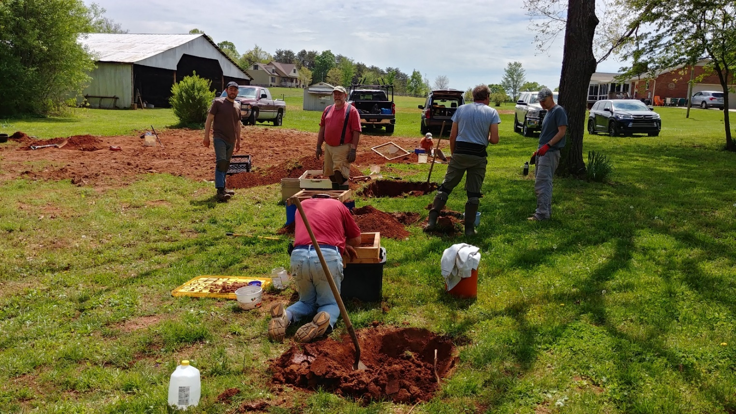

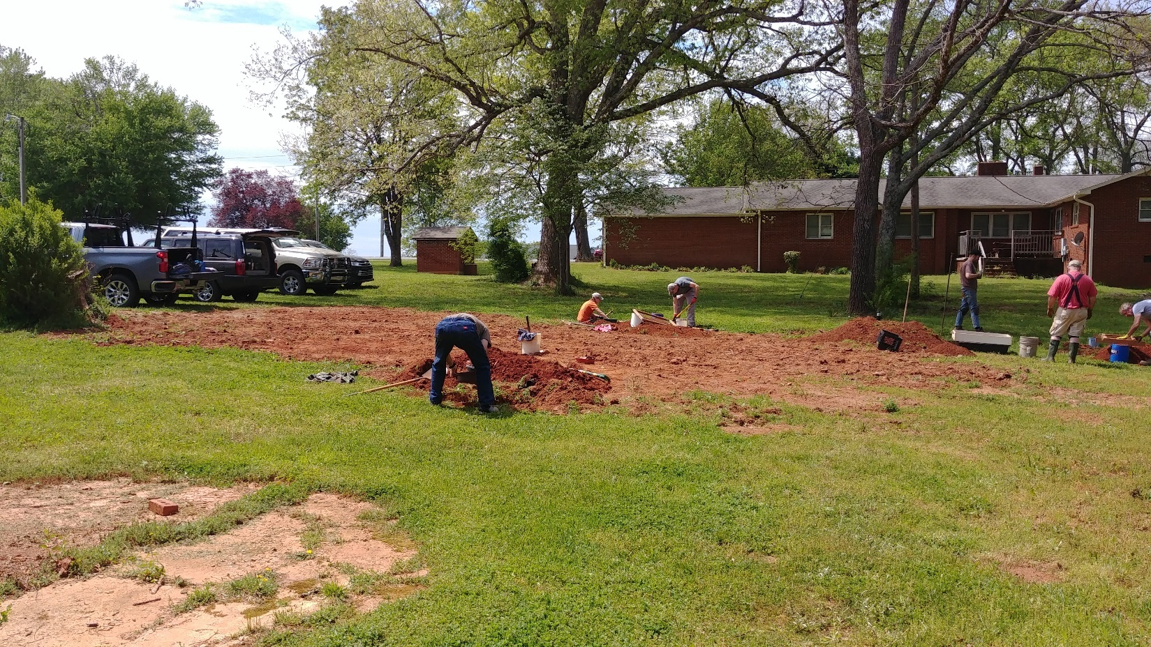

|  |  |  |
| --- | --- | --- |
|  | **FGMC Meeting Minutes 3/18/2021** |  |

15 participants

Our speaker was Ed Speer. Topic “The Legend of the Brown Mountain Lights.” Ed has also written a book titled The Minerals of Hiddenite, North Carolina published by McFarland Books ([www.mcfarlandbooks.com](http://www.mcfarlandbooks.com)).

FGMC to sponsor 2 scholarships at Sawtooth Center, Winston-Salem, NC. These scholarships would be in honor of long-standing FGMC members Paul Burton and Dick Hartz. Paul Burton was an expert faceter and Dick Hartz was a great cabochon cutter.

The faceting class (in Paul’s honor) is a 4- week class with a cost of $270.00. The cabochon cutting class (in Dick’s honor) is a 4- week class with a cost of $230.00. The Club will vote in May on sponsoring these scholarships in 2021.

J.P. Timberlake is donating a childhood rock/mineral collection to FGMC. This collection will be sold at the club auction.

FGMC show news:

Reservations have been made for picnic shelter in August 2021. Picnic and grab bag “put together” will be held Covid rules permitting. Dealer show contracts have been received for FGMC Show Sept. 10-12, 2021.

Upcoming shows:

* Franklin, NC – May
* Grassy Creek, Spruce Pine – July
* Franklin Club Show in Community Center Building has been cancelled for July, 2021.

Respectfully submitted by,  
Lisa Reed, Secretary FGMC

**Forsyth Gem and Mineral Club, Inc.  
Minutes from Board of Directors Meeting May 10, 2021 7:30 pm EDT**

The Board met via Zoom with six of the eight members in attendance:

* Charles Whicker
* Ken Reed
* Lisa Reed
* Jay Wilhelmi
* Sherry Marion
* Stephanie Myers

Items for discussion and decision:

1. Appointment of Jay Wilhelmi to fill the Treasurer’s position vacated by Alex McGilvary’s death;
2. Appointment of Scott Brouhle to fill the Director’s position now vacated by Jay Wilhelmi;
3. Vote on resolution to change signatories on bank accounts;
4. Decide on a permanent address for the Club;
5. Discuss changing our registered agent;
6. Discuss setting up an e-mail address for the Club;
7. Discuss setting up a PayPal account for the Club;
8. Discuss updating the Club’s website;
9. Discuss presenting the proposal for the Sawtooth scholarships to the general membership.

Outcome of discussion on items above:

1. A motion was made and seconded to appoint Jay Wilhelmi to fill the Treasurer’s Office for the remainder of the current year – vote was unanimous in favor – Jay is the new Treasurer.
2. A motion was made and seconded to appoint Scott Brouhle to fill the Director’s office previously held by Jay – vote was unanimous in favor – Scott is now a Director.
3. A motion was made and seconded to add Jay Wilhelmi and Charles Whicker as signatories on the Piedmont Federal account for the Club’s Dues Account and to remove Martin Alex McGilvary as he is deceased. Vote was unanimous in favor.  
   3A. Motion was made and seconded to remove Paul Burton as signatory from the Club’s Show Fund account as he is deceased. Vote was unanimous in favor.
4. A motion was made and seconded to obtain a P. O. Box as the permanent address of the Club – this will eliminate the changes of address each time there is a change in officers. (Information is that the cost will be approximately $120 per year). Vote was unanimous in favor. Jay was instructed to procure said P. O. Box at a place most convenient for him, and to get at least three keys, if possible.
5. It has been noted that the Registered Agent on file with the N.C. Secretary of State is a prior member that is no longer a member and most probably deceased. Options discussed were, to set up another current member as Registered Agent, or to set up with a business that provides Registered Agent service. Motion was made and seconded to utilize North Carolina Registered Agent in Raleigh, N.C. (information is $49 per year for this service). Vote was unanimous in favor.
6. Directors discussed an e-mail address for the Club. It was noted that “contact@forsythgemclub.com” had been seen on some documents. Directors are to contact Wayne Ketner to see if he has any info on this address before any further action is taken.
7. A PayPal account was discussed and several issues were discussed. More information is to be gathered prior to any action on this issue. (a club e-mail address will be required before activating a PayPal account).
8. Charlie stated that the website has not had an update since mid-2020, and suggested that it would be beneficial to put a “public version” of the newsletter on the site monthly. Jay Wilhelmi (newsletter editor) is to work with Stephanie Myers (webmaster) to implement this process.
9. Charlie had e-mailed to directors the finalized proposal for the scholarships that the Club is considering for the Sawtooth Center. A motion was made and seconded to put this proposal in the May newsletter and indicate that it will be voted on by the general membership during the May (zoom) meeting. Vote on the motion was unanimous in favor.

Meeting was adjourned until the additional information required is gathered.

Lisa J. Reed  
Secretary  
FGMC, Inc.

FORSYTH GEM AND MINERAL CLUB, INC.

Membership Application

For the Year 2021

Date ______________

Member Name: ______________________________________________________

|  |  |  |
| --- | --- | --- |
| Additional Family Names: | ____________________ | ____________________ |
|  | ____________________ | ____________________ |
|  | ____________________ | ____________________ |

Address: ___________________________________________________________________

Street City State Zip

**Telephone Home (____) __________________**

**Work (____) ___________________**

**E-Mail Address** **______________________________________________________________**

**Annual Dues of $15.00** are payable January 1 for the current year, per family (mailing address). Dues are reduced to $8.00 per family, if joining after July 1 of the year.

**Checks should be made to:** **Forsyth Gem and Mineral Club, Inc.**

I am interested in the following activities (check all that apply):

|  |  |  |
| --- | --- | --- |
| ___Mineral Collecting | ___Fossils | ___Gold or Silver Smithing |
| ___Lapidary | ___Faceting | ___Carving |
| ___Jewelry Making | ___Wire Wrapping | ___Other _____________ |

**I would like to help with the Annual Gem and Mineral Show? Yes No**

**Circle Yes or No**

|  |  |
| --- | --- |
| **Areas needing volunteers work in are:** |  |
| Setup & Display Case Assembly | Display Case Takedown and Loading |
| Club Area Setup & Table Covering | Dealer Dinner |
| Admission & Information | Geode Cutting (Saw Operator) |
| Grab Bag, Geode, and Gold Panning Sales |  |

Please **complete** and **return to the Club’s Treasurer, Jay Wilhelmi, at the address below.**

**Jay Wilhelmi  
Treasurer  
Forsyth Gem and Mineral Club  
P.O. Box 422  
Pfafftown, NC 27040**

***Nature’s Treasures***

Nature’s Treasures is the monthly newsletter of the Forsyth Gem and Mineral Club.

|  |  |  |
| --- | --- | --- |
| **President:** | Charles Whicker | [ccwhicker@live.com](mailto:ccwhicker@live.com) |
| **Vice President:** | Ken Reed | [mckinleycreed@bellsouth.net](mailto:mckinleycreed@bellsouth.net) |
| **Secretary:** | Lisa Reed | [lisajreed@bellsouth.net](mailto:lisajreed@bellsouth.net) |
| **Treasurer:** | Jay Wilhelmi | [jhwilhelmi@gmail.com](mailto:jhwilhelmi@gmail.com) |
| **Directors:** | Scott Brouhle |  |
|  | Sherry Marion |  |
|  | Stephanie Myers |  |
|  | Jeff Schlottman |  |
| **Hospitality Chair:** | Open |  |
| **Newsletter Editor:** | Jay Wilhelmi | [jhwilhelmi@gmail.com](mailto:jhwilhelmi@gmail.com) |
| **Web Master:** | Stephanie Myers |  |