**FORSYTH GEM AND MINERAL CLUB, INC.**

***Nature's Treasures***

***June 13, 2021***

 **MEETING**: Due to the ongoing Covid-19 (Coronavirus) lockdown, the next meeting of the Forsyth Gem and Mineral Club will be a virtual Zoom meeting on Thursday, June 17, 2021 at 7:30 pm. Follow the link in the invitation below to attend.

** PROGRAM**: The next meeting of the Forsyth Gem and Mineral Club will be Thursday, June 17th at 7:30 pm. Once again, we will be having a virtual meeting via Zoom. Follow the link in the invitation below to attend. You can participate with a computer, tablet or smart phone.

Program Note: Our speaker for June is Geoff Krasnov. Some of you may know or remember Geoff as a mineral dealer in our show some years back. He runs GeoKrazy Minerals, and is a collector that specializes in Calcites. Geoff will be presenting a program on the Calcites of the Tsumeb Mine, Namibia. Tsumeb is a quite famous copper mine that produced many exceptional mineral specimens.

Charles Whicker is inviting you to a scheduled Zoom meeting.  
Topic:   
Time: June 17, 2021 7:30 pm Eastern Time (US and Canada)

Join Zoom Meeting

<https://us02web.zoom.us/j/86072487144?pwd=dkZuN3BNSHZDcno2YklObDJYNG4zdz09>

Meeting ID: 860 7248 7144  
Passcode: 105359  
One tap mobile  
+13017158592,,86072487144#,,,,*105359# US (Washington DC)  
+13126266799,,86072487144#,,,,*105359# US (Chicago)

Dial by your location  
        +1 301 715 8592 US (Washington DC)  
        +1 312 626 6799 US (Chicago)  
        +1 646 558 8656 US (New York)  
        +1 253 215 8782 US (Tacoma)  
        +1 346 248 7799 US (Houston)  
        +1 669 900 9128 US (San Jose)

Meeting ID: 860 7248 7144  
Passcode: 105359

Find your local number: <https://us02web.zoom.us/u/kemcyUrgEI>

|  |  |  |
| --- | --- | --- |
|  | **Forsyth Gem and Mineral Club Show News** |  |

**This is our “field trip” for September and we will need all hands-on deck!** At present there is still a question of whether we can have the dealer dinner as usual, however it should be answered well in advance for planning.

I can now say we have received confirmation that Vulcan Materials will sponsor WTOB to broadcast live from our 50th show on Saturday September 11th from 10:00 AM until 4:00 PM. In addition, there will be announcements and interviews on WTOB for several weeks preceding the show.

We have lined up as presentations, Alex Glover, Geologist - who will speak on the Spruce Pine Mining District, and Jim Stroud, Geologist – who will speak on N.C. Minerals Past Present and Future (these two are in-person). The Reed Gold Mine Historical Site has committed to do a presentation on N.C. Gold, either in person or via ZOOM, and we are working with the N.C. Natural History Museum to get one or two ZOOM presentations on the N.C. Minerals they have in their collection.

Special t-shirts are being created to commemorate our Golden Anniversary. At this time, we plan to produce medium, large and extra-large Hanes beefy tees. Should anyone desire a larger size shirt, let me know.

Arvil Marion

|  |  |  |
| --- | --- | --- |
|  | **Other Dates to Remember** |  |

**August 14, 2021**  
FGMC picnic at Hathaway Park in Winston-Salem on Saturday, August 14th from 3:00 pm until 7:00 pm. This is our usual location. The street address is 301 Anita Drive. A fun afternoon of grab bag packing, food and fellowship with club members!

**August 21, 2021**  
Jeff Schlottman has arranged for another club auction! Details will be coming in future newsletters.

The above two events will replace a field trip in August.

**September 9, 2021**  
FGMC’s Fabulous 50th Anniversary Gem and Mineral Show Deal Dinner if permitted. Stay tuned for future announcements.

|  |  |  |
| --- | --- | --- |
|  | **Upcoming Gem and Mineral Shows** |  |

**June 18 – 20, 2021 ARDEN, N.C.**  
Annual show; MAGMA, Jacquot & Son Mining; Camp Stephens, 263 Clayton Road. Hours: Friday – Saturday 10:00 am to 6:00 pm, Sunday 10:00 am to 4:00 pm. Free admission. 13th annual gem, mineral and fossil show. Dozens of vendors offering gems, minerals, fossils, rocks, artifacts, and meteorites, among other items. Contact Richard Jacquot, P.O. Box 542, Leicester, N.C. 28748, (828) 779-4501; Email: [rick@wncrocks.com](mailto:rick@wncrocks.com); Website: [www.AmericanRockhound.com](http://www.AmericanRockhound.com).

**June 19 – 20, 2021 GASTONIA, N.C.**  
Gaston Gem, Mineral, and Faceters Club presents its Summer Gemboree, 42nd Annual Gem, Mineral, and Jewelry Show, Saturday 10:00 am to 6:00 pm, Sunday 10:00 am to 4:00 pm, at the John Newcombe Event Center, 1840 E. Franklin Boulevard, Gastonia, N.C. 28054. Minerals, fossils, gemstones, jewelry, gem mining ($5 and $10 buckets), and much more!

|  |  |  |
| --- | --- | --- |
|  | **Club News** |  |

**New Mailing Address**

The Forsyth Gem and Mineral Club has a new mailing address. From now on please address any correspondence to:

Forsyth Gem and Mineral Club  
P.O. Box 422  
Pfafftown, NC 27040

|  |  |  |
| --- | --- | --- |
|  | **Micro-Photography** |  |

**Micro Photography – A New World of Discovery and Sharing**

Collecting rocks, minerals and fossils has fascinated me for as long as I can remember and my interest has never waned. The obsession was so great that I decided to study geology in college and persisted until I was awarded a Ph.D. Whether it be rocks and minerals, or fossils, I have always found examination of the specimens that I collect to be a fascinating portal into a distant past. This sense of childhood wonder remains with me even to today whenever I investigate an outcrop to see what discoveries await.

Although some specimens are best viewed in hand sample with a hand lens at most for magnification, another world of wonders awaits those that further examine their finds with a binocular microscope. I find this especially true of fossils, but it holds true for crystals and micro minerals as well. I have enjoyed doing so for many years with my college lab surplus equipment, but until recently was unable to share my discoveries with others, not having the means to photograph what I saw. I always thought that it would be necessary to purchase a new scope with an attached camera to make that happen. Recently, out of frustration, I “Googled” retrofitting microscopes with cameras to see what might be available. To my surprise, I found that there are a number of options for attaching Smart phones with cameras to the ocular of a microscope. After a quick assessment, I settled on a model that would accommodate both the diameter of my ocular and fit my phone model for a mere $20. I immediately ordered one. The model that I chose can also be attached to binoculars and telescopes! Set up is easy and although it takes a bit of maneuvering to get alignment of the phone camera lens with the microscope ocular, I have been able to get more than adequate pictures and would highly recommend purchase of such a unit by anyone with similar equipment and interests.

In short, the adaptor is small, light-weight, plastic and slips easily over the outside frame of the phone like an outer band that can be tightened like a vice. In my case, I am using an Android Pixel phone that has on/off and volume buttons on the side that are slightly problematic as it precludes me from sliding the attachment onto the phone beyond one third its length. This makes the arrangement slightly less stable than it would otherwise be, but still quite manageable. Attached to the back side of the phone-gripping vice is a second plastic piece with an opening that fits over the ocular. A simple turn of the circular cap-like fitting ratchets the attachment tightly against the ocular. Once anchored, the ocular fitting is then rotated and moved along a cross bar on the vice until it aligns with the phone camera lens. This is the only tricky part as it requires careful adjustment to assure direct view of the light being projected through the ocular, but is certainly not difficult. Doing so brought to mind the Apollo movie wherein the capsule was maneuvered to bring the earth into view!

There are a number of such attachments that are available to purchase that you can use to photograph your specimens through a microscope, but the one that I settled on was a “Spotting Scope Smartphone… for Binocular Monocular” - available through Amazon. For those of you that have a microscope and would like to share your discoveries with others, I highly recommend experimenting with this or similar equipment. Happy viewing!

Brian Grothaus  
(WESCAGEM)

Reprinted from SFMS Lodestar Newsletter June 2021

|  |  |  |
| --- | --- | --- |
|  | **FGMC Scholarships** |  |

In order to honor two former venerable members of the FGMC, to support the local lapidary arts department at Sawtooth School of Visual Arts and to hopefully attract new members from the local arts community, FGMC intends to establish two scholarships at Sawtooth. The name of the scholarships shall be “The Dick Hartz Cabbing Scholarship” and “The Paul Burton Faceting Scholarship”.

Sawtooth has agreed to handle the administration, advertising of the scholarships and selection of the winners, based upon the following preferences: a candidate who intends to use the knowledge obtained in a future business or education in lapidary arts, a candidate who displays an existing background in lapidary arts, and any candidate that has a financial need that is not already receiving financial assistance. However, none of these preferences shall be considered a requirement or disqualification for any candidate. Sawtooth will notify FGMC of the winners and the reason for their selection. FGMC intends to include a free membership to the winners for the concurrent calendar year.

At this time, the cost of both scholarships total about $500. That amount will cover one student for the cabbing class and one student for the faceting class for one session each, or one class per week for four weeks. FGMC intends to use the proceeds from our yearly club auction, a 50/50 raffle when we meet in person again and individual donations to finance the scholarships. We will need to pay the funds in advance to Sawtooth, who will keep the funds in a designated account and give FGMC periodic account balances. FGMC intends to pay the funds each January for the following year. Currently, there is $500 in the account from an individual donation. If funds allow, FGMC may sponsor more than two students per year.

|  |  |  |
| --- | --- | --- |
|  | **DMC Field Trips Cancelled for 2021 Schedule Moving Forward One Year** |  |

I hope everyone is healthy and safe as we enter this new year. COVID-19 vaccines are providing some post-COVID optimism. We are nearing a time when we can share field trips with one another again.

Unfortunately, even with vaccines available, it appears that the virus may still be a problem this year. Until we know for certain that we can gather together safely, we must approach the situation with great caution.

So, in the interest of safety, I am moving the entire DMC schedule forward by another year.

All trips scheduled for 2021 are moved to 2022, 2022 to 2023, 2023 to 2024, and 2024 to 2025.

The new schedule is posted on the SFMS website here: [http://www.amfed.org/sfms/_dmc/dixie-proposed-ft.htm](https://amfed.us12.list-manage.com/track/click?u=80754e4f918a2ae19a26a2449&id=ccb09d1d91&e=825de0a403)

Please let me know if you have any questions.

Many thanks to all of the clubs who continue to support the DMC Field Trip Sharing Program as we work our way through this.

Stay healthy, stay safe.

Lori Carter  
DMC Coordinator

|  |  |  |
| --- | --- | --- |
|  | **Upcoming Field Trips** |  |

* **June 19, 2021** - Little Pine Garnet Mine, Marshall, Madison County, NC. See documentation attached at the end of this newsletter with map, hold harmless agreement, and details.
* **July 17, 2021** - Danville, Kentucky area for Kentucky geodes with a possible side trip for fluorite, more details to come.

|  |  |  |
| --- | --- | --- |
|  | **May Field Trip Report** |  |

On May 22nd the club visited Fairy Stone Park in Virginia to collect staurolite crystals. Attendees were Al Gaskil, Stephanie Myers, Brian Burdette, Jay Wilhelmi and Charles Whicker. Brian took us to his “secret” collecting spot off the beaten path and into the woods where we found lots of crystals just under the leaves. Several very nice 90-degree crosses were found and we all found lots of singles and 30-degree clusters. The weather was warm, but we were under the shade trees so it was not uncomfortable. Each of us collected a number of crystals to place in grab bags for the show in September. Thanks to Brian for guiding us and thanks to all attendees for a very enjoyable day.

Charles Whicker

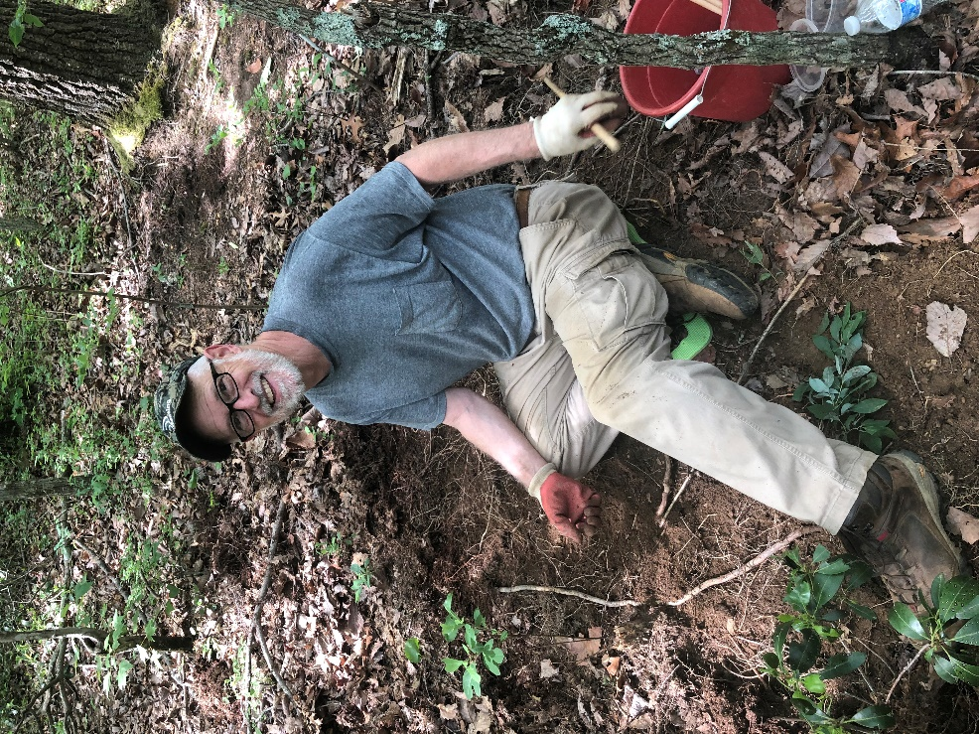 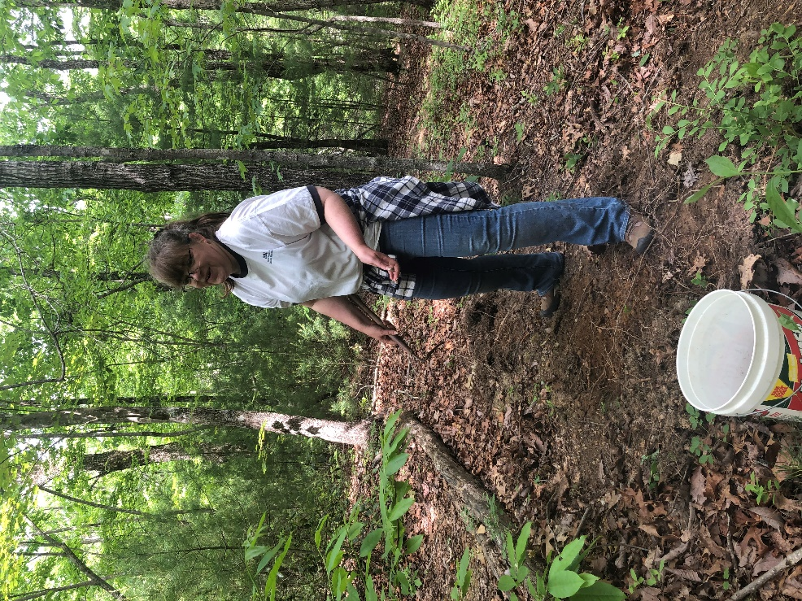

If you don’t want to venture into the woods to dig up your own staurolite crystals you could always feed the vending machine at the Fairy Stone Pit Stop.

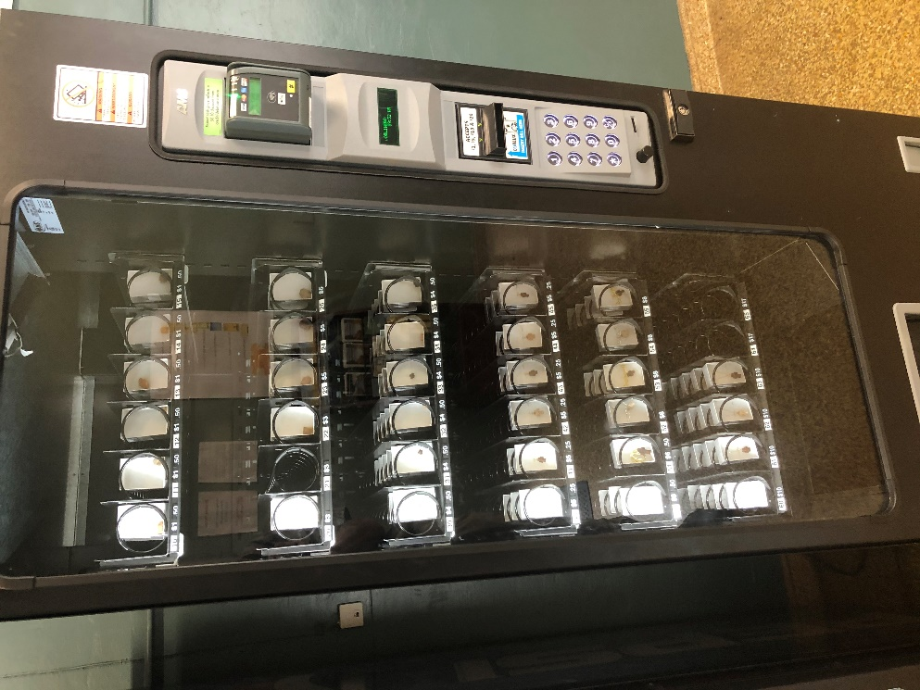

|  |  |  |
| --- | --- | --- |
|  | **FGMC Meeting Minutes 5/20/2021** |  |

20 members attended the ZOOM meeting.

Evan Jones presented the topic “Mining at the Milpillas Mine” Sonora, Mexico. He is also the owner of Unique Minerals, Inc. in Cave Creek, Arizona.

Upcoming events:

* Greensboro Club Show- June 5th. Booths still available. Rental on 10x10 foot booth space $60.
* Sawtooth Center- Summer 2021 courses: two cabbing classes, one faceting class, one Turquoise class.

Vote on two scholarships to be awarded at Sawtooth Center 2021. This is a $500.00 value – one-$270.00 value for a faceting class, and one-$230.00 value for a cabbing class. These scholarships are in honor of Paul Burton and Dick Hartz who were long-time club members and experts in faceting and cabbing. Money to fund these scholarships will be raised by 50/50 raffle at meetings, club auctions, and individual contributions. Motion to fund two scholarships at Sawtooth Center. Motion carried by unanimous vote. Charlie Whicker will coordinate with Sawtooth for the award of these scholarships.

With the passing of our Treasurer Alex McGilvary, Jay Wilhelmi has been appointed Treasurer FGMC.

Scott Brouhle has been appointed as a Director to fill the seat vacated by Jay.

Upcoming Field trips:

* Fairy Stone State Park – May 22
* Kentucky Geodes –fossil geodes - July field trip. Clarksville, KY and Danville, KY. 6-7 hours each way, possibly three-day trip to include geode collecting and collecting at Mundy’s Landing – Fluorite Mine.

Respectfully submitted by,  
Lisa Reed, Secretary FGMC

FORSYTH GEM AND MINERAL CLUB, INC.

Membership Application

For the Year 2021

Date ______________

Member Name: ______________________________________________________

|  |  |  |
| --- | --- | --- |
| Additional Family Names: | ____________________ | ____________________ |
|  | ____________________ | ____________________ |
|  | ____________________ | ____________________ |

Address: ___________________________________________________________________

Street City State Zip

**Telephone Home (____) __________________**

**Work (____) ___________________**

**E-Mail Address** **______________________________________________________________**

**Annual Dues of $15.00** are payable January 1 for the current year, per family (mailing address). Dues are reduced to $8.00 per family, if joining after July 1 of the year.

**Checks should be made to:** **Forsyth Gem and Mineral Club, Inc.**

I am interested in the following activities (check all that apply):

|  |  |  |
| --- | --- | --- |
| ___Mineral Collecting | ___Fossils | ___Gold or Silver Smithing |
| ___Lapidary | ___Faceting | ___Carving |
| ___Jewelry Making | ___Wire Wrapping | ___Other _____________ |

**I would like to help with the Annual Gem and Mineral Show? Yes No**

**Circle Yes or No**

|  |  |
| --- | --- |
| **Areas needing volunteers work in are:** |  |
| Setup & Display Case Assembly | Display Case Takedown and Loading |
| Club Area Setup & Table Covering | Dealer Dinner |
| Admission & Information | Geode Cutting (Saw Operator) |
| Grab Bag, Geode, and Gold Panning Sales |  |

Please **complete** and **return to the Club’s Treasurer, Jay Wilhelmi, at the address below.**

**Forsyth Gem and Mineral Club  
P.O. Box 422  
Pfafftown, NC 27040**

***Nature’s Treasures***

Nature’s Treasures is the monthly newsletter of the Forsyth Gem and Mineral Club.

|  |  |  |
| --- | --- | --- |
| **President:** | Charles Whicker | [ccwhicker@live.com](mailto:ccwhicker@live.com) |
| **Vice President:** | Ken Reed | [mckinleycreed@bellsouth.net](mailto:mckinleycreed@bellsouth.net) |
| **Secretary:** | Lisa Reed | [lisajreed@bellsouth.net](mailto:lisajreed@bellsouth.net) |
| **Treasurer:** | Jay Wilhelmi | [jhwilhelmi@gmail.com](mailto:jhwilhelmi@gmail.com) |
| **Directors:** | Scott Brouhle |  |
|  | Sherry Marion |  |
|  | Stephanie Myers |  |
|  | Jeff Schlottman |  |
| **Hospitality Chair:** | Open |  |
| **Newsletter Editor:** | Jay Wilhelmi | [jhwilhelmi@gmail.com](mailto:jhwilhelmi@gmail.com) |
| **Web Master:** | Stephanie Myers |  |

|  |  |  |
| --- | --- | --- |
|  | **June Field Trip Little Pine Garnet Mine, Madison County (Near Marshall, N.C.)** |  |

Many of us have visited Little Pine before and never came away empty handed. Actually, in past trips decisions had to be made on which pieces were worth keeping. Matrix specimens of garnet crystals in chlorite schist are normally abundant as well as loose garnets up to 3” with 1” to 2” being common. The matrix specimens clean up very nicely and have a good contrast of color between the red/brown garnets and the green/gray matrix. Some elongated crystals are found here and occasionally a single staurolite will occur.

THE OLD “CAVE-TYPE” MINE ADIT IS NOW OFF LIMITS TO COLLECTING!!!

History: Little Pine was worked commercially around 1904-05 for Garnets to be crushed and used in making sandpaper (garnet paper). The trip will take about two-and-a-half to three hours from Winston-Salem. The mine is operated by Sandy Bottom Trail Rides, 1459 Caney Fork Road Marshall, NC 28753 – telephone 1-800-959-3513. A map is included to get you to the Trail Rides office (once you leave Highway 25-70 there will also be signs directing you to the Sandy Bottom Trail Rides office) where you will pay your fee and turn in the liability release. The fee is $30 per day per person (9:00 am to 5:00 pm), with a collecting limit of one bucket per person.

Meet at Sandy Bottom Trail Rides at 10:00 am. Directions and parking information will be available at the office, but I am including what I have below:

DO NOT GO TO THE MINE SITE WITHOUT FIRST VISITING THE OFFICE – THEY PROVIDE A “TICKET” THAT YOU MUST KEEP WITH YOU AND IS SUBJECT TO BEING CHECKED!!

Coming out from the Sandy Bottom Trail Rides office – go left at the intersection of Caney Fork and Little Pine Roads. About on-half mile, turn left onto Roberts Branch Road (SR-1127). Follow Roberts Branch Road 4/10th of a mile and turn left onto a gravel drive. Follow this drive thru the creek, (yes, no bridge and only shallow water normally) - park in the wide area on the right. DO NOT BLOCK THIS DRIVE!! – it is a driveway to a home or homes farther on. PLEASE VERIFY THIS INFO AT THE OFFICE – I have not personally visited this location in a few years, drives get paved, mailboxes moved, road signs torn down, etc.

Each individual will be required to sign the liability waiver (copy also included). Please print as many as you need for EACH individual in your group. Minor children will need a parent or guardian to also sign their form.

Tools – You will be digging in tailings/spoils piles or dumps. A bucket to transport your finds (limit of one bucket per person). A small pick or mattock, small shovel, rock hammer, screw driver, small prybar will be handy. (Scratching and splitting tools). Not all are needed, but something to turn the piles, and help in selecting pieces to collect. The Garnets are in a fine-grained mica/chlorite schist, which sometimes needs splitting to reveal the crystals.

Bring snacks, drinks/water (no store close by), and bug repellant if nature finds you tasty. There may be port-o-lets at the actual mine area, and there are facilities at the mine office. Otherwise, there are many trees – and you may want to include some “necessary paper-work”.

As with all sites, make sure to pick up your trash, do not block drives or roadways when parking, avoid digging in gravel drives, damaging fences/gates, or straying onto adjacent property. Being a responsible, cooperative group will help assure us the ability to return.

Ken Reed

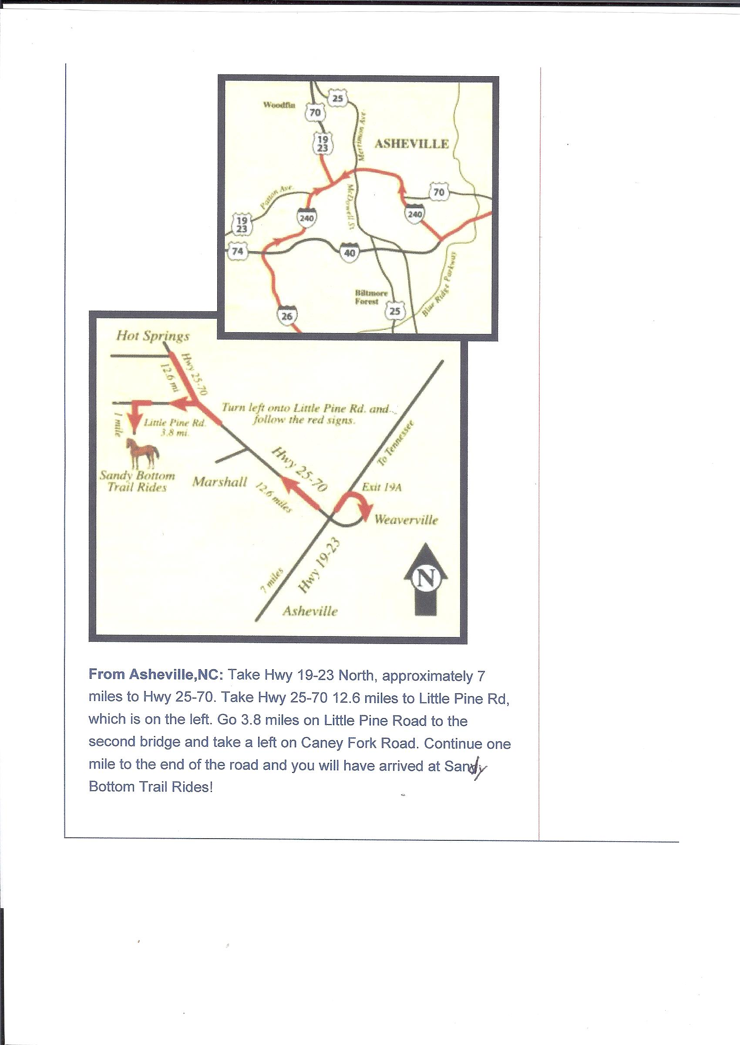

**PARTICIPANT AGREEMENT, RELEASE AND ASSUMPTION OF RISK**

In consideration of the services of Sandy Bottom Trail Rides LLC & Long Pine Gem Mine*/*Little Pine Garnett Mine, their agents, owners, officers, volunteers, participants, employees, and all other persons or entities acting in any capacity on their behalf (hereinafter collectively referred to as “SBTR & LPGM”), I hereby agree to release, indemnify, and discharge SBTR & LPGM, on behalf of myself, my spouse, my children, my parents, my heirs, assigns, personal representative and estate as follows:

1.I acknowledge that my participation in horseback riding, carriage, sleigh or wagon ride, Kubota rides and digging*/*mining activities entails known and unanticipated risks that could result in physical or emotional injury, paralysis, death, or damage to myself, to property, or to third parties. I understand that such risks simply cannot be eliminated without jeopardizing the essential qualities of the activity.

**The risks may include, but are not limited to:** exposure to and travel in rugged terrain, collisions, and flipping over; slipping and falling; falling into open pits or trenches; the collapse of excavations; equipment failure; exposure to potentially dangerous wild animals, insect bites, and hazardous plant life; exposure to temperature and weather extremes; being jolted, jarred, bounced, thrown about and otherwise shaken during rides; it is possible that riders could be injured if they come into contact with other passengers; losing control of your horse and falling; my own physical condition, and the physical exertion associated with this activity. A horse, regardless of its training and usual past behavior, may act unpredictably at times based upon instinct or fright which may cause you to be thrown from your horse or injured by the horse. Horses may do such things as bite, kick, buck, lie down, or stumble. Saddles may slip and other tack or saddle problems may develop as a result of normal use and wear. Your horse may collide with obstacles or encounter variations in terrain such as creeks, water, bridges, traveled roads, wild animals, birds, stumps, forest growth, debris, rocks and cliffs and other obstacles whether obvious or not and whether man made or natural. Riding a horse requires the participant to balance on the saddle. Accidents or illness can occur in remote places without medical facilities and emergency treatment or other services rendered.

Furthermore, SBTR & LPGM employees have difficult jobs to perform. They seek safety, but they are not infallible. They might be unaware of a participant's fitness or abilities. They might misjudge the weather or other environmental conditions. They may give incomplete warnings or instructions, and the equipment being used might malfunction.

2. I expressly agree and promise to accept and assume all of the risks existing in this activity. My participation in this activity is purely voluntary, and I elect to participate in spite of the risks.  
3. I hereby voluntarily release, forever discharge, and agree to indemnify and hold harmless SBTR & LPGM from any and all claims, demands, or causes of action, which are in any way connected with my participation in this activity or my use of SBTR & LPGM’s equipment or facilities, **including any such claims which allege negligent acts or omissions of SBTR & LPGM.**   
4. Should SBTR & LPGM or anyone acting on their behalf, be required to incur attorney's fees and costs to enforce this agreement, I agree to indemnify and hold them harmless for all such fees and costs.   
5. I certify that I have adequate insurance to cover any injury or damage that may cause or suffer while participating, or else I agree to bear the costs of such injury or damage myself. I further certify that I am willing to assume the risk of any medical or physical condition I may have.   
6. In the event that I file a lawsuit against SBTR *&* LPGM, I agree to do so solely in the state of North Carolina, and I further agree that the substantive law of that state shall apply in that action without regard to the conflict of the law rules of that state. I agree that if any portion of this agreement is found to be void or unenforceable, the remaining portions shall remain in full force and effect.

**By signing this document, I acknowledge that if anyone is hurt or property is damaged during my participation in this activity, I may be found by a court of law to have waived my right to maintain a lawsuit against SBTR *&* LPGM on the basis of any claim from which I have released them herein.**

**I have had sufficient opportunity to read this entire document. I have read and understood it, and I agree to be bound by its terms.**

Signature of Participant: _______________________________________ Print Name: __________________________________________________

Address_________________________________________________________________________________________________________________

Phone____________________________________________________________Date___________________________________________________

**PARENT'S OR GUARDIAN'S ADDITIONAL INDEMNIFICATION**

**(Must be completed for participants under age of 18)**

In consideration of____________________________________________________(print minor's name)(“Minor”) being permitted by SBTR & LPGM to participate in its activities and to use its equipment and facilities, I further agree to indemnify and hold harmless SBTR & LPGM from any and all Claims which are brought by, or on behalf of Minor, and which are in any way connected with such use or participation by Minor.

Parent or Guardian:____________________________________Print Name:__________________________Date:________________