**FORSYTH GEM AND MINERAL CLUB, INC.**

***Nature's Treasures***

**HAPPY NEW YEAR!**

***January 17, 2022***

**MEETING**: Due to the ongoing Covid-19 (Coronavirus) lockdown, the next meeting of the Forsyth Gem and Mineral Club will be a virtual Zoom meeting on Thursday, January 20, 2022 at 7:30 pm. Follow the link in the invitation below to attend.

** PROGRAM**: The next meeting of the Forsyth Gem and Mineral Club will be Thursday, January 20, 2022 at 7:30 pm. Once again, we will be having a virtual meeting via Zoom. Follow the link in the invitation below to attend. You can participate with a computer, tablet or smart phone.

Program Note: The program for the January meeting will be a discussion of our 2022 field trip schedule. If you have any ideas or would like to host a trip please join us. I would like to add a trip for September after our show for new members. I would also like to brainstorm a way for us to have a sign-up sheet so none of our hosts find themselves as the only participant. Additionally, we have the opportunity to visit several out of state sites and I would like to gauge how much interest the group has in overnight trips. Any schedule will be tentative and subject to change as the year progresses.

Charles Whicker is inviting you to a scheduled Zoom meeting.  
Topic: FGMC Field Trips for 2022  
Time: January 20, 2022 at 7:30 pm Eastern Time (US and Canada)

Join Zoom Meeting

<https://us02web.zoom.us/j/86721380708?pwd=VkdMQitRUXRJN21RVGM3cDM5OFVJdz09>

Meeting ID: 867 2138 0708

Passcode: 945713

One tap mobile

+13126266799,,86721380708#,,,,*945713# US (Chicago)

+16465588656,,86721380708#,,,,*945713# US (New York)

Dial by your location

        +1 312 626 6799 US (Chicago)

        +1 646 558 8656 US (New York)

        +1 301 715 8592 US (Washington DC)

        +1 346 248 7799 US (Houston)

        +1 669 900 9128 US (San Jose)

        +1 253 215 8782 US (Tacoma)

Meeting ID: 867 2138 0708

Passcode: 945713

Find your local number: <https://us02web.zoom.us/u/kdsfpCU9xL>

|  |  |  |
| --- | --- | --- |
|  | **2022 Membership Renewal** |  |

A number of 2021 FGMC members have not yet renewed their memberships for 2022. (You know who you are!) Past members who have not renewed to date are receiving this newsletter as a courtesy. Please renew as soon as possible. There is a renewal application included with this newsletter.

As an encouragement to renewal, the Club will conduct a raffle for members who join or renew their memberships before February 28, 2022. (Members means family unit as appropriate.) There will be two prizes. Winners will be chosen at our March 17, 2022 regular membership meeting.

* 1st Prize – $25 Visa Gift Card
* 2nd Prize – $15 Value 2023 FGMC Family Membership

**If you joined at the Club Show last September and paid $15 you are paid in full for 2022 and eligible to participate in this raffle.**

Please note that current FGMC officers, officials, committee chairs or directors (you know who you are) are ineligible for these prizes. Also, if the March membership meeting is in person or via Zoom you need not be present or logged in to win – although you are strongly encouraged to do so.

If you have any questions concerning renewal, please contact the Club Treasurer, Jay Wilhelmi.

|  |  |  |
| --- | --- | --- |
|  | **Sawtooth Scholarship Awarded** |  |

The Board of Directors of FGMC are pleased to announce that The Dick Hartz Cabbing Scholarship has been awarded to Ashley Dunkle of Fayetteville, North Carolina. In addition to covering the expenses of a four-week cabbing class at Sawtooth School of Visual Arts here in Winston-Salem, Ms. Dunkle will also receive a complimentary one-year Club membership. Congratulations, Ashley Dunkle! We look forward to seeing your lapidary masterpieces!

|  |  |  |
| --- | --- | --- |
|  | **Upcoming Gem and Mineral Shows** |  |

**4th Annual SFMS Rockhound Round-Up  
February 18 – 20, 2022  
Suwannee River Music Park, Live Oak, Florida**

It's time again to register for the Annual SFMS Rockhound Roundup! I can't believe we've been doing this for four years now! Every year we add to the number of vendors and increase our attendance. We expect that we will continue to grow hopefully to become the Quartzite of South Florida. There are only two requirements to participate: you must be a member of an SFMS Club and your products need to be rock related. In the past, we have had members representing their clubs and businesses from every state in the Southeast Federation. The fee for a 10 x 20 space is $50 for the whole weekend. What a bargain! Obviously we would prefer that you stay for the entire event, but you can reserve space for one or more days, we just ask that you be setup by 9:00 am each day. Your placement may be affected by the number of days you reserve.

We will be spending some bucks advertising on Facebook this year, and hope to draw more visitors from around the state and local area. We've had a professional flyer designed, and will try to beef up promotion with PSA’s and perhaps some radio announcements.

If you have any questions, please contact Jerri Heer at 419-344-9999 or [secretary@southeastfed.org](mailto:secretary@southeastfed.org).

(Application to participate in the Round-up is attached at the end of the newsletter.)

**Catawba Valley Gem Mineral Show  
March 25 – 27, 2022  
Hickory, North Carolina**

The Catawba Valley Gem and Mineral Club will hold their Golden Anniversary gem, mineral, fossil, and jewelry show on March 25, 26, and 27, 2022 at the Hickory Metro Convention Center. The convention center is located at 1960 13th Avenue Drive SE, in Hickory, North Carolina. Hours are 10:00 a. till 6:00 pm on Friday, 10:00 am till 6:00 pm on Saturday, and 10:00 am till 5:00 p. on Sunday. Admission is $5.00 which is good for all three days. Children 12 and under are admitted free. Law enforcement officers and active or retired military with credentials, Scouts and Leaders in uniform will be admitted free anytime during this 3-day event.

Scheduled are many educational displays and presentations that will be in operation during regular show hours. Some of the areas will include florescent minerals, wire-wrapping, cabochoning, faceting, and other lapidary arts. Other glass-enclosed displays will feature high quality specimens from many United States locations and other countries. Drawings for regular door prizes will be held every hour. The club will be selling grab bags containing minerals and fossils for $1.00 each for as long as they last.

The web page for the club is www.cvgmc.com Special Events. For additional information concerning the show, contact Dean Russell, show chairman, at [cvgmcsecretary@aol.com](mailto:cvgmcsecretary@aol.com) or (828) 303-1448.

|  |  |  |
| --- | --- | --- |
|  | **January Field Trip** |  |

FGMC’s January field trip will be held on Saturday, January 22, 2022, between 10:00 am to 12:00 noon at the Joe Gutierrez Earth Science Museum of Vulcan Materials Company, 4401 North Patterson Avenue, Winston-Salem, North Carolina.

Below is a map to access the Museum from Patterson Avenue. Enter off of Patterson Avenue, turn right past the Division Office and follow the drive up the hill to the Museum.

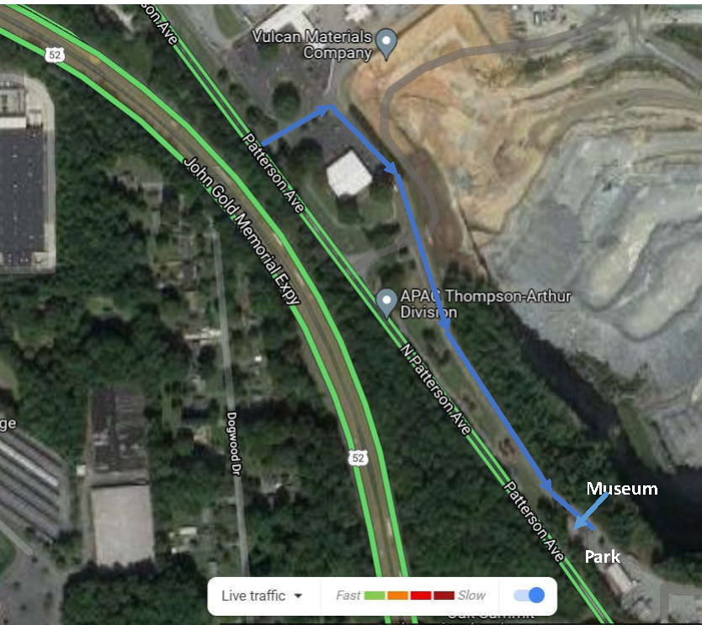

We will meet at 10:00 am outside the Museum. Please note the following:

* We must wear masks and social distance while inside the Museum.
* The Museum is limited to 10-12 persons. If more than that show up we can have some wait outside and take advantage of viewing the North Quarry pit from an overlook, then rotate through the Museum so that all can get a peek.

Over the years the Club has donated several specimens and showcases to the Museum, which is named for a former Club member and Vulcan geologist. Denise Hallett, our Vulcan liaison, will be hosting, and we hope the local geologist will also be in attendance. Denise is interested in getting club members input on how to improve the Museum. Vulcan hosts school groups there throughout the year in a partnership with Kaledium North.

Ken Reed

|  |  |  |
| --- | --- | --- |
|  | **December 2021 Meeting Minutes** (and Seconds for Those Who Went through the Buffet Line More than Once) |  |

30 members participating

Our December meeting was an enjoyable dinner and time of fellowship at Golden Corral for members that had volunteered to serve or joined FGMC at our September Gem and Mineral Show. We all love rocks and minerals and there was no trouble finding a topic to discuss.

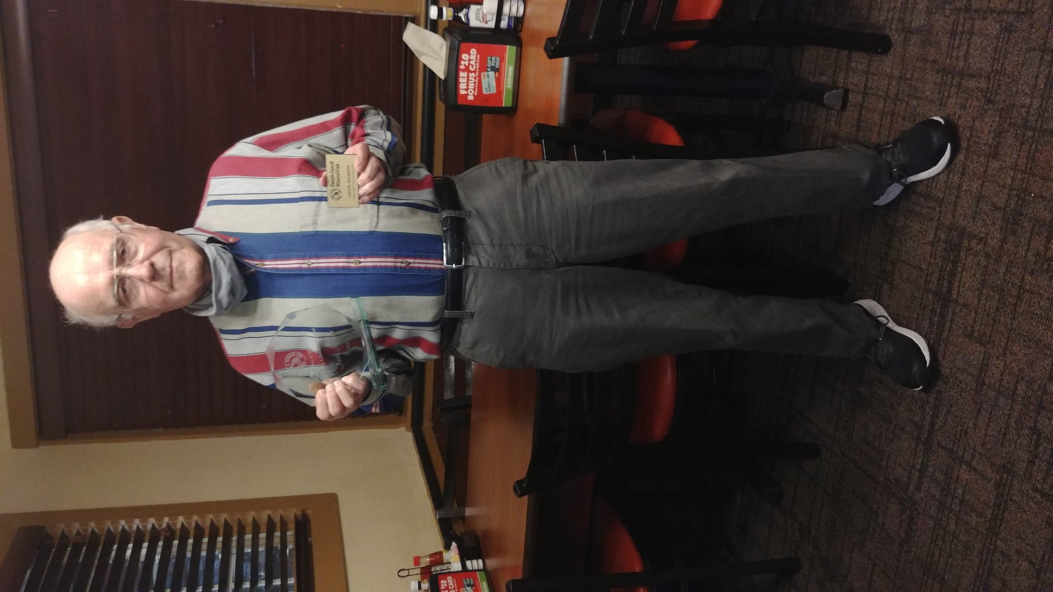

Our President Charles Whicker and Vice President Ken Reed awarded Arvil Marion an engraved obelisk to commemorate his efforts in being FGMC Show Chairman. He also received an engraved nametag and Honorary Lifetime Club membership.

Respectfully submitted by Lisa Reed,   
Secretary FGMC

FORSYTH GEM AND MINERAL CLUB, INC.  
Membership Application  
For the Year 2022

**Date: ______________**

**Member Name: ______________________________________________________**

|  |  |  |
| --- | --- | --- |
| **Additional Family Members:** | **________________________________** | **________________________________** |
|  | **________________________________** | **________________________________** |
|  | **________________________________** | **________________________________** |

**Address: __________________________________________________________________________________**

**Street City State Zip**

**Telephone(s): Home: (____) ___________________ Work: (____) ___________________**

**Cell-1: (____) ___________________ Cell-2: (____) ___________________**

**E-Mail Address-1: ___________________________________________@_____________________________**

**E-Mail Address-2: ___________________________________________@_____________________________**

**Annual Dues of $15.00 are payable January 1st for the current year, per family (mailing address). Dues are reduced to $8.00 per family, if joining after July 1st of the year.**

**Checks should be made to: Forsyth Gem and Mineral Club, Inc.**

**I am interested in the following activities (check all that apply):**

|  |  |  |
| --- | --- | --- |
| **___ Mineral Collecting** | **___ Fossils** | **___ Gold or Silver Smithing** |
| **___ Lapidary** | **___ Faceting** | **___ Carving** |
| **___ Jewelry Making** | **___ Wire Wrapping** | **___ Other _______________** |

**I would like to help with the Annual Gem and Mineral Show? Yes No**

**Circle Yes or No**

|  |  |
| --- | --- |
| **Areas needing volunteers work in are:** |  |
| **Setup & Display Case Assembly** | **Display Case Takedown and Loading** |
| **Club Area Setup & Table Covering** | **Dealer Dinner** |
| **Admission & Information** | **Geode Cutting (Saw Operator)** |
| **Grab Bag and Geode Sales** |  |

**Please complete and return to the Club’s Treasurer, Jay Wilhelmi, at the address below.**

**Forsyth Gem and Mineral Club  
P.O. Box 422  
Pfafftown, NC 27040**

***Nature’s Treasures***

Nature’s Treasures is the monthly newsletter of the Forsyth Gem and Mineral Club.

|  |  |  |
| --- | --- | --- |
| **President:** | Ken Reed |  |
| **Vice President:** | Charles Whicker |  |
| **Secretary:** | Lisa Reed |  |
| **Treasurer:** | Jay Wilhelmi |  |
| **Directors:** | Scott Brouhle |  |
|  | Sherry Marion |  |
|  | Stephanie Myers |  |
|  | Jeff Schlottman |  |
| **Hospitality Chair:** | Jeanne Schlottman |  |
| **Newsletter Editor:** | Jay Wilhelmi |  |
| **Web Master:** | Stephanie Myers |  |

**Southeast Federation Mineralogical Societies, Inc.  
Rockhound Roundup Application  
February 18-20, 2022  
Suwannee River Music Park, Live Oak, FL**

We hope this will continue to be a successful Rockhound Roundups sponsored by the SFMS. Each SFMS member who applies for and is accepted, will be allotted a 10’ x 20’ space in an open field designated for this event. Cost this year is a minimal $50.00 per space, one space per Vendor, for one to all three days. No tents, tables or chairs are available, you MUST BRING YOUR OWN! This is intended to be an old-fashioned rock swap and sale - bring your pickup, drop the tailgate and have fun.

Name: _______________________________________________________________________

Address: _____________________________________________________________________

Phone: ____________________________ Cell: ___________________________

Email: _______________________________________________________________________

SFMS Club Affiliation: ___________________________________________________________

Vehicle Make/Model: _________________________ Plate#: ____________________________

Will you have a tent? Yes _________ No __________

Applicant Signature____________________________________ Date ____________________

Your signature indicates acceptance of the terms and conditions outlined in this two-page document.

Send Application and check made out to SFMS to:

SFMS Secretary  
Jerri Heer  
9016 122nd Avenue  
Tampa, FL 33637-5321

______________________________________for office use

only_______________________________________

Date form was received: _______________ By: __________________ Check # ___________Check $

___________

Space assignment: Row: __________________ Space: _______________________

**SFMS Fourth Annual  
Rockhound Roundup**

**Set-up:** Friday- Sunday, February 18-20, 2022 each day from 7 am – 9 am. Check in at the SFMS Welcome tent.  
All vendor vehicles must be in place by 9 am. Swap and sales start each day at 9 am, ending at 4 pm.

**Venue Info:**

1. Restrooms are available inside the Suwannee River Music Park at the Music Hall and Café.
2. ATM machine is available in the General Store.
3. Housing: Cabins, RV Space and campsites are available in the Park. Call Carol Walker at (386)365-0070 for reservations. If you don’t reach her, leave a message, she will call you back. Please indicate that that you are with the Rockhound Roundup as they are tracking our participation. You may also reserve online at [www.musicliveshere.com](http://www.musicliveshere.com) or by calling the main line (386)364-1683.
4. Hotels: In addition to accommodations onsite, there are several hotels nearby. Go to <https://www.musicliveshere.com/directions-maps/> for a list.
5. The General Store and Café has food available onsite and as take out. We are attempting to arrange one or more food trucks, but that is not finalized at this time. You are welcome to bring your own food and beverages.

**SFMS Responsibilities:**

1. Provide a marked 10’ x 20’ space and vehicle access to the space.
2. Provide access to trash receptacles.
3. Provide access to toilet facilities.

**Applicant/Vendor Responsibilities**

1. Set-up within boundaries of provided space. Any changes to the designated space are only allowed at the discretion of the Roundup Committee.
2. Police assigned site for trash during and after event.
3. You are responsible for your own security. You may set-up and tear down each day.
4. Provide all equipment, tents, tables and chairs for your own set-up.

We ask that you please be understanding that as we continue to grow this event, we are in a learning curve as to what works best. We will try to anticipate all reasonable needs. Our goal is to provide a smooth event, but there will likely be hiccups along the way. All of us are volunteers trying to make this an enjoyable event for all. We welcome your suggestions and ideas for improvement. You may email questions to [Secretary@southeastfed.org](mailto:Secretary@southeastfed.org).