**FORSYTH GEM AND MINERAL CLUB, INC.  
*Nature's Treasures  
February 13, 2022***

**MEETING**: Due to the ongoing Covid-19 (Coronavirus) lockdown, the next meeting of the Forsyth Gem and Mineral Club will be a virtual Zoom meeting on Thursday, February 17, 2022 at 7:30 pm. Follow the link in the invitation below to attend.

** PROGRAM**: The next meeting of the Forsyth Gem and Mineral Club will be Thursday, February 17, 2022 at 7:30 pm. Once again, we will be having a virtual meeting via Zoom. Follow the link in the invitation below to attend. You can participate with a computer, tablet or smart phone.

Program Note: The program for the February meeting will be a presentation by our President, Ken Reed, on North Carolina gold. Some of you may have seen it at our 50th Anniversary Show. He will include information on gold discoveries, mining, extraction methods and photos. We know that he likes to talk, particularly about something he enjoys, and North Carolina minerals is one of his favorite subjects!

Please join us.

Charles Whicker is inviting you to a scheduled Zoom meeting.  
Topic: North Carolina Gold  
Time: February 17, 2022 at 7:30 pm Eastern Time (US and Canada)

Join Zoom Meeting

<https://us02web.zoom.us/j/89758766722?pwd=b3MzN2wyQ0dMd0dDUG9RYmZpYVUxQT09>

Meeting ID: 897 5876 6722

Passcode: 916633

One tap mobile

+16465588656,,89758766722#,,,,*916633# US (New York)

+13017158592,,89758766722#,,,,*916633# US (Washington DC)

Dial by your location

        +1 646 558 8656 US (New York)

        +1 301 715 8592 US (Washington DC)

        +1 312 626 6799 US (Chicago)

        +1 669 900 9128 US (San Jose)

        +1 253 215 8782 US (Tacoma)

        +1 346 248 7799 US (Houston)

Meeting ID: 897 5876 6722

Passcode: 916633

Find your local number: <https://us02web.zoom.us/u/kcL4JgRK1p>

|  |  |  |
| --- | --- | --- |
|  | **2022 Membership Renewal** |  |

A number of 2021 FGMC members have not yet renewed their memberships for 2022. (You know who you are!) Past members who have not renewed to date are receiving this newsletter as a courtesy. Please renew as soon as possible. There is a renewal application included with this newsletter.

As an encouragement to renewal, the Club will conduct a raffle for members who join or renew their memberships before February 28, 2022. (Members means family unit as appropriate.) There will be two prizes. Winners will be chosen at our March 17, 2022 regular membership meeting.

* 1st Prize – $25 Visa Gift Card
* 2nd Prize – $15 Value 2023 FGMC Family Membership

**If you joined at the Club Show last September and paid $15 you are paid in full for 2022 and eligible to participate in this raffle.**

Please note that current FGMC officers, officials, committee chairs or directors are ineligible for these prizes. Also, if the March membership meeting is in person or via Zoom you need not be present or logged in to win – although you are strongly encouraged to do so.

If you have any questions concerning renewal, please contact the Club Treasurer, Jay Wilhelmi at 336-403-2218 or [jhwilhelmi@gmail.com](mailto:jhwilhelmi@gmail.com).

|  |  |  |
| --- | --- | --- |
|  | **Mineral Monday on Social Media** |  |

We have received the following notice from Dr. Chris Tacker of the North Carolina Natural History Museum:

Hi, y’all,

This is the International Year of Mineralogy. I’m trying to start a Mineral Monday post on social media, but our communications office is too understaffed to support it. So I can post pictures and info on my own site.

I've started a Twitter account at drchristacker. I'll be posting all sorts of NC mineral pictures as part of Mineral Monday and the Year of Mineralogy. These will all be from the Geology Collection.

I'll also be posting the same to Instagram, at DrChrisTacker.

Could you please pass this on to your membership? The more people we can get following these accounts, the more likely we are to convince people that there is widespread interest in North Carolina minerals.

Plus stay tuned. We are in the very first stages of planning an event for Earth Science Week in October.

Thank you very much,  
Chris Tacker

Chris Tacker *(he, him, his)*

Research Curator, Geology | Ph.D., P.G.,   
North Carolina Museum of Natural Sciences | 11 West Jones Street | Raleigh, NC 27601-1029  
<http://www.naturalsciences.org/>

|  |  |  |
| --- | --- | --- |
|  | **Message from the President** |  |

I want to welcome new members and those who have renewed their memberships. Remember, if you join or renew by February 28, 2022, you will have a chance at the $25 gift card, or the free family membership for 2023!

This has been a trying time for our organization. In addition to the shrinking opportunities for field trips, the restrictions on “in person” meetings have been a negative in many ways. Our leadership is always looking for ways to improve our activities, and the “virtual” meetings have allowed us to take advantage of presenters who would have never been available in person. We also need our members to constantly be looking for potential field trips sites. This could be a friend who has a site, or simply contacting a “thought to be closed” site to see if we can gain access. If you have ideas on prospective sites, please let Charlie or me know. We will gladly assist if we can.

If anyone has ideas on improving our organization, please e-mail or discuss them with an officer or board member. Even if the particular idea you present is not adopted, making us re-think our long-standing processes, can bring about improvements that were just never before brough to mind.

I am not sure about you, but I am looking forward to a time when we will hear “virtual” less, and “hands on” more!

Happy and safe collecting!  
Ken

|  |  |  |
| --- | --- | --- |
|  | **On-Line Signup for Field Trips** |  |

Stephanie Myers, our Web Master and computer wizard, has set up a sign-up “sheet” on the Club’s web site. We would like for members to use this to indicate their intention to attend our February 19th field trip to the Joe Gutierrez Earth Science Museum of Vulcan Materials Company at Vulcan Materials (see field trip information, below). This is not a requirement. However, due to the erratic attendance of recent field trips, we wanted an easily accessible place for trip leaders to see who, how many, and/or if anyone, will be attending the upcoming trip(s). Initially, Ken Reed will receive a notification each time someone signs up. This may change, as we are still in the “development stage” of this process.

|  |  |  |
| --- | --- | --- |
|  | **Annual Club Picnic** |  |

This year we are moving the location of our annual club picnic. After searching for a better location, we decided to try Tanglewood Park this year. We have reserved Shelter No. 2 for August 13, 2022. It will be ours for the day.

There are 18 picnic tables, two “serving tables”, 71 parking spaces, and clean restrooms! For those who remember the downpour at last year’s picnic, this shelter is large enough to huddle in the center and NOT GET WET!

The club has prepaid for our members to enter the park, so there will be not “per car” fee. Please plan ahead to attend, mingle with your fellow rockhounds, and be gathering stuff for grab bag packing! There will be more details as we get closer to the date.

|  |  |  |
| --- | --- | --- |
|  | **Annual Club Auction** |  |

We have spoken with Jeff Schlottman, and he has planned the annual club auction for August 27, 2022. Again, please plan to participate in this event. Details will be forthcoming as we get neared to the date.

|  |  |  |
| --- | --- | --- |
|  | **Annual Club Show** |  |

We are already working on our Gem and Mineral Show for Friday, Saturday & Sunday, September 9th, 10th & 11th - with our set-up on Thursday the 8th. This year’s theme is**: Precious and** **semi-precious gemstones and Crystals.** Please mark your calendars, and plan to participate. We all work hard but also have a great time! We have a great group of dealers and members, and we can find time to socialize as well as put on the show!

|  |  |  |
| --- | --- | --- |
|  | **A Message from Your Southeast Federation of Mineral Societies (SFMS) Education Committee!** |  |

**William Holland School of Lapidary Arts & Wildacres Retreat**

The new workshop website is online and ready for student signups. At this time, we only have the William Holland week listed as we’re still working on instructors for Wildacres. I would like to thank Lori and Charles Carter for their help and hard work in getting this site online and functioning. And for helping me through the setup process. We have an online application form as well as a PDF registration. We can also accept PayPal for the class deposit. To access the classes, go to: <https://www.sfmsworkshops.org/>.

**William Holland Classes (6/5 – 11/2022)**

* Seed Beaded Cabs Jerri Heer
* Cabs II Paul Roberts
* Low-Tech Casting Debora Mauser
* Enameling I Samantha Lazzaro
* Soft Solder Becky Patellis
* Flame Painting Bob Hohn
* Intarsia II Bill Boggs
* Silver I Valerie LaMott
* Leather I Tom Slavicek
* Wire II Gene Sheridan
* Chasing & Repousse Guy Meador

**Wildacres I (8/22 – 28/2022)**

* Casting Bill Harr
* Metal Mania Cindy Moore
* Chain Maille Jim Hird
* Special Projects Jeff Sheer
* TBD Jason Hamilton
* Wire 1 and Beyond Rhonda Stevens

**Wildacres II (9/12 – 18/2022)**

* Casting Bill Harr
* Metal Mania Cindy Moore
* Chain Maille Marilou Hillenbrand
* Inlay Chuck Bruce
* Knapping Guy Meador
* TBD Jason Hamilton

Best regards,

Lisa Roberts  
2022 SFMS Education Committee

Cindy Reed  
SFMS WH-Registrar and Workshop Website Coordinator

|  |  |  |
| --- | --- | --- |
|  | **Upcoming Gem and Mineral Shows** |  |

**Catawba Valley Gem Mineral Show  
March 25 – 27, 2022  
Hickory, North Carolina**

The Catawba Valley Gem and Mineral Club will hold their Golden Anniversary gem, mineral, fossil, and jewelry show on March 25, 26, and 27, 2022 at the Hickory Metro Convention Center. The convention center is located at 1960 13th Avenue Drive SE, in Hickory, North Carolina. Hours are 10:00 a. till 6:00 pm on Friday, 10:00 am till 6:00 pm on Saturday, and 10:00 am till 5:00 p. on Sunday. Admission is $5.00 which is good for all three days. Children 12 and under are admitted free. Law enforcement officers and active or retired military with credentials, Scouts and Leaders in uniform will be admitted free anytime during this 3-day event.

Scheduled are many educational displays and presentations that will be in operation during regular show hours. Some of the areas will include florescent minerals, wire-wrapping, cabochoning, faceting, and other lapidary arts. Other glass-enclosed displays will feature high quality specimens from many United States locations and other countries. Drawings for regular door prizes will be held every hour. The club will be selling grab bags containing minerals and fossils for $1.00 each for as long as they last.

The web page for the club is www.cvgmc.com Special Events. For additional information concerning the show, contact Dean Russell, show chairman, at [cvgmcsecretary@aol.com](mailto:cvgmcsecretary@aol.com) or (828) 303-1448.

|  |  |  |
| --- | --- | --- |
|  | **January Field Trip** |  |

FGMC’s February field trip scheduled for Saturday, January 22, 2022, was CANCELLED due to adverse weather and rescheduled for February. See below.

|  |  |  |
| --- | --- | --- |
|  | **February Field Trip** |  |

FGMC’s February field trip will be held on Saturday, February 19, 2022, between 10:00 am to 12:00 noon at the Joe Gutierrez Earth Science Museum of Vulcan Materials Company, 4401 North Patterson Avenue, Winston-Salem, North Carolina.

Below is a map to access the Museum from Patterson Avenue. Enter off of Patterson Avenue, turn right past the Division Office and follow the drive (in **blue**) up the hill to the Museum.

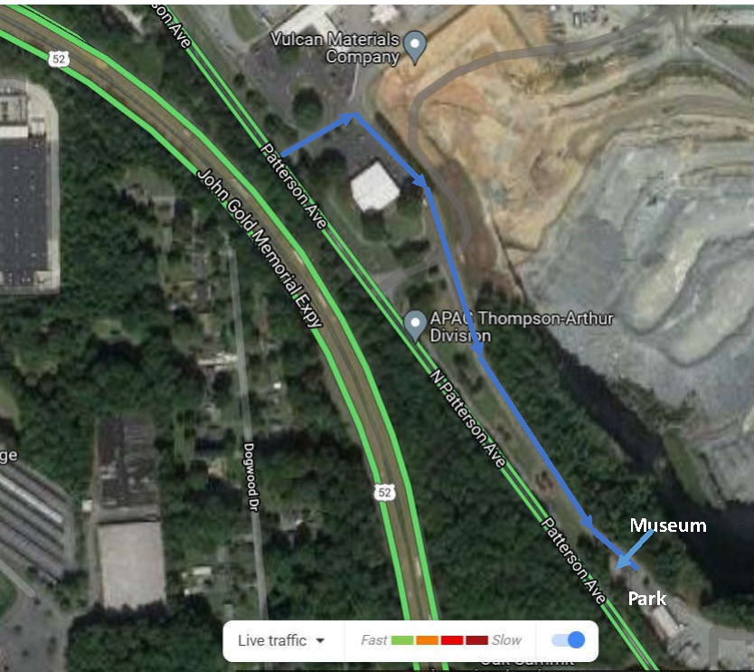

We will meet at 10:00 am outside the Museum. Please note the following:

* We MUST wear masks and social distance while inside the Museum.
* The Museum is limited to 10-12 persons. If more than that show up we can have some wait outside and take advantage of viewing the North Quarry pit from an overlook, then rotate through the Museum so that all can get a peek.

Over the years the Club has donated several specimens and showcases to the Museum, which is named for a former Club member and Vulcan geologist. Denise Hallett, our Vulcan liaison, will be hosting, and we hope the local geologist will also be in attendance. Denise is interested in getting club members input on how to improve the Museum. Vulcan hosts school groups there throughout the year in a partnership with Kaledium North.

Ken Reed

|  |  |  |
| --- | --- | --- |
|  | **January 2022 Meeting Minutes** |  |

January 20, 2022 FGMC Meeting Minutes

Zoom meeting with 14 members participating.

The January Meeting is our annual meeting to discuss field trip locations and dates for the coming year. Since pandemic rules and weather can change our planning of fieldtrips, pay attention to emails and newsletter confirmation of locations and dates.

Quorum of members was declared, and a motion to hold a FGMC show in September 2022 was seconded and passed.

Respectfully submitted by Lisa Reed,   
Secretary FGMC

FORSYTH GEM AND MINERAL CLUB, INC.  
Membership Application  
For the Year 2022

**Date: ______________**

**Member Name: ______________________________________________________**

|  |  |  |
| --- | --- | --- |
| **Additional Family Members:** | **________________________________** | **________________________________** |
|  | **________________________________** | **________________________________** |
|  | **________________________________** | **________________________________** |

**Address: __________________________________________________________________________________**

**Street City State Zip**

**Telephone(s): Home: (____) ___________________ Work: (____) ___________________**

**Cell-1: (____) ___________________ Cell-2: (____) ___________________**

**E-Mail Address-1: ___________________________________________@_____________________________**

**E-Mail Address-2: ___________________________________________@_____________________________**

**Annual Dues of $15.00 are payable January 1st for the current year, per family (mailing address). Dues are reduced to $8.00 per family, if joining after July 1st of the year.**

**Checks should be made to: Forsyth Gem and Mineral Club, Inc.**

**I am interested in the following activities (check all that apply):**

|  |  |  |
| --- | --- | --- |
| **___ Mineral Collecting** | **___ Fossils** | **___ Gold or Silver Smithing** |
| **___ Lapidary** | **___ Faceting** | **___ Carving** |
| **___ Jewelry Making** | **___ Wire Wrapping** | **___ Other _______________** |

**I would like to help with the Annual Gem and Mineral Show? Yes No**

**Circle Yes or No**

|  |  |
| --- | --- |
| **Areas needing volunteers work in are:** |  |
| **Setup & Display Case Assembly** | **Display Case Takedown and Loading** |
| **Club Area Setup & Table Covering** | **Dealer Dinner** |
| **Admission & Information** | **Geode Cutting (Saw Operator)** |
| **Grab Bag and Geode Sales** |  |

**Please complete and return to the Club’s Treasurer, Jay Wilhelmi, at the address below.**

**Forsyth Gem and Mineral Club  
P.O. Box 422  
Pfafftown, NC 27040**

***Nature’s Treasures***

Nature’s Treasures is the monthly newsletter of the Forsyth Gem and Mineral Club.

|  |  |  |
| --- | --- | --- |
| **President:** | Ken Reed |  |
| **Vice President:** | Charles Whicker |  |
| **Secretary:** | Lisa Reed |  |
| **Treasurer:** | Jay Wilhelmi |  |
| **Directors:** | Scott Brouhle |  |
|  | Sherry Marion |  |
|  | Stephanie Myers |  |
|  | Jeff Schlottman |  |
| **Hospitality Chair:** | Jeanne Schlottman |  |
| **Newsletter Editor:** | Jay Wilhelmi |  |
| **Web Master:** | Stephanie Myers |  |