FORSYTH GEM AND MINERAL CLUB, INC.

Nature's Treasures
May 15, 2022
'1t',WIf'tlMEETING: GOOD NEWS! The next meeting of the Forsyth Gem and Mineral Club will be held at 7:30 pm on Thursday, May 19, 2022 in person at Vulcan Materials Company's Training Center, 4401 N. Patterson Avenue, Winston-Salem, N.C.

•■•■ PROGRAM: Our speaker for the May meeting will be an encore presentat ion by our member Brian Burdette. Brian' s program this month will be entitled "Is that a REAL Gemstone?" The presentation will include definitions about what is real, what is natural, what is manmade and what is imitation. We will include discussions about modifiers, adjectives, and misuse of mineral names to misidentify products. We will end with a question-and-answer session and examples of "misleading" product names.

It should be a most interesting presentation. Please come join us if you are able!

ZOOM Meeting Information

Topic: FGMC May Meeting
Time: May 19, 2022, 7:30 pm Eastern Time (US and Canada)

Join Zoom Meeting
https://us02web.zoom.us/j/8186 0980764?pwd=GhA- Uyole LVlj-UH-8Gq2qFy2yxoFz.1

Meeting ID: 818 6098 0764
Passcode: 023773 One tap mobile
+13017158592,,81860980764#,,,,*023773# US (Washington DC)
+13126266799,,81860980764#,,,,*023773# US (Chicago)

Dial by your location
+1 301 715 8592 US (Washington DC)
+l 312 626 6799 US (Chicago)
+1 646 558 8656 US (New York)
+1 253 215 8782 US (Tacoma)
+1 346 248 7799 US (Houston)
+1 669 900 9128 US (San Jose)
Meeting ID: 818 6098 0764
Passcode: 023773
Find your local number: https://us02web.zoom.us /u/kbaH1IuB0k

Refreshments

Refreshments for the meeting will be provided by the Brouhle and Hummond families. The Club will provide cups and napkins. Volunteers need only provide sufficient drinks and snacks such as cookies, cake, crackers, nuts, fruit, et cetera.

2022 Refreshment List

January | Zoom Call Meeting | July | Shelton & Grimes
February | Zoom Call Meeting | August | Annual Picnic
March | Schlottman & Whicker | September | Gem & Mineral Show
April | Myers & Wilhelmi | October | Two (2) Needed
May | Hummond & Brouhle | November | Arvil & Reed
June | Goode & One (1) Needed | December | Holiday/Show Dinner

If you are willing to volunteer to provide refreshments, please speak to our Hospitality Chair at any meeting or Club event. If you are unable to attend for any reason, please contact her prior to the meeting so that alternate arrangements can be made.
Thanks so much for volunteering!
Note: Due to equipment issues in the meeting area kitchen, it will be necessary for the refreshments providers to also bring ice for the drinks.

I Message from the President
As of now, the volunteers to assist with the updating of the Vulcan Museum, including myself are:

- Stephanie Myers
- Sherry Marion
- Arvil Marion

Anyone wishing to contribute to this Club project needs to let me know by the end of May. We will plan to begin our work when the school year ends and group visits to the museum are at a minimum. The project involves: making new labels for the specimens, cleaning the showcases, possibly adding bases for the specimens, and reworking the ultraviolet display.

Ken Reed

I Mineral Monday on Social Media
Are you following Dr. Chris Tacker of the North Carolina Natural History Museum on social media? If not, you're missing a treat.

He posts on Twitter at drchristacker and Instagram at DrChrisTacker. He posts all sorts of North Carolina mineral pictures as part of Mineral Monday and the Year of Mineralogy. These will all be from the Geology Collection.

I Opal Notes from April's Meeting
Thanks to Brian Burdette for providing the following notes from his presentation last month on cutting opals.

- Sources of Cutting Rough - Australia (check out https://blackopaldirect.com and watch Justin's videos on YouTube), Ethiopia, Mexico, US, Honduras and Indonesia.
- Never buy rough opal stored in water or glycerin! Especially Ethiopian and Mexican opals.
- Have a plan. Cut for fun or cut for profit. Rough opal can be expensive.
- Buy from a reputable source!
- Cut for the best quality stone and not for carat weight.
- Test various surfaces of the color bar to determine the brightest direction.
- "Candle" the rough to find potential cracks and inclusions.
- Mount your stone on a dop stick for the best control of the cutting process.
- Dop wax versus super glue. Both work well but super glue does not stick to wooden dops.
- Don't TEMPERATURE SHOCK your opals. Heat slowly, cool slowly. Do not remove the stone from the dop in ice water or the freezer!!!! Acetone is OK for opals.
- Roughly grind the stone to the desired shape, stopping occasionally to look for defects. For expensive opal rough, I may study the stone many times before the final cutting. This is especially true for Ethiopian opal as cracks may show up during or days after the grinding process.
- Opal is relatively soft so take it slow and easy to prevent over cutting a stone, especially small stones. Stay off the coarser wheels as much as possible.
- Grind, sand, and polish as you would most gemstones. Scratched surfaces are not part of the preferred finish! Cerium Oxide polishes the best.
- Australian opals usually remain stable once finished and are ready for sale or setting.
- Once finished, you may want to let the stone "age" for a few days to assure stability.
- For Ethiopian and Mexican opals, let the stone "age" for a few days to assure stabilit y. It may take a month or more for the moisture content to stabilize. Give it some time before selling or setting the stone. Trust me on this!
- Never store opal in water except for strictly display purposes.
- Never store opal climate-controlled storage boxes.

I Annual Club Picnic
This year we are moving the location of our annual club picnic. After searching for a better location, we decided to try Tanglewood Park this year. We have reserved Shelter No. 2 for August 13, 2022. It will be ours for the day.

There are 18 picnic tables, two "serving tables", 71 parking spaces, and clean restrooms! For those who remember the downpour at last year's picnic, this shelter is large enough to huddle in the center and NOT GET WET!

The club has prepaid for our members to enter the park, so there will be not "per car" fee. Please plan ahead to attend, mingle with your fellow rockhounds, and be gathering stuff for grab bag packing! There will be more details as we get closer to the date.

I Annual Club Auction
We have spoken with Jeff Schlottman, and he has planned the annual club auction for August 27, 2022. Again, please plan to participate in this event. Details will be forthcoming as we get neared to the date.

I Annual Club Show
We are already working on our Gem and Mineral Show for Friday, Saturday & Sunday, September 9¹
\

10th & 11th

- with our set-up on Thursday the 8th• This year's theme is: Precious and semi-precious gemstones and Crystals. Please mark your calendars, and plan to participate. We all work hard but also have a great time! We have a great group of dealers and members, and we can find time to socialize as well as put on the show!

A Message from Your Southeast Federation of Mineral Societies (SFMS) Education Committee! (I)
I

William Holland School of Lapidary Arts & Wildacres Retreat

The new workshop website is online and ready for student signups. At this time, we only have the William Holland week listed as we're still working on instructors for Wildacres. I would like to thank Lori and Charles Carter for their help and hard work in getting this site on line and functioning. And for helping me through the setup process. We have an online application form as well as a PDF registration. We can also accept PayPal for the class deposit. To access the classes, go to: https://www.sfmsworkshops .or g/.

William Holland Classes (6/5 - 11/2022) Wildacres I (8/22 - 28/2022)

- Seed Beaded Cabs | Jerri Heer | - Casting | Bill Harr
- Cabs II | Paul Roberts | - Metal Mania | Cindy Moore
- Low-Tech Casting | Debora Mauser | - Chain Maille | Jim Hird
- Enameling I | Samantha Lazzaro | - Special Projects | Jeff Sheer
- Soft Solder | Becky Patellis | - TBD | Jason Hamilton
- Flame Painting | Bob Hohn | - Wire 1 and Beyond | Rhonda Stevens
- Intarsia II | Bill Boggs
- Silver I Valerie LaMott Wildacres II (9/12 - 18/2022)
- Leather I Tom Slavicek • Casting Bill Harr
- Wire II Gene Sheridan • Metal Mania Cindy Moore
- Chasing & Repousse Guy Meador • Chain Maille Marilou
Hillenbrand
  - Inlay Chuck Bruce
  - Knapping Guy Meador
  - TBD Jason Hamilton
Best regards,
Lisa Roberts
2022 SFMS Education Committee
Cindy Reed
SFMS WR-Registrar and Workshop Website Coordinator

A Message from Your Southeast Federation of Mineral Societies (SFMS) Education Committee! (II)
I

William Holland School of Lapidary Arts Needs New Instructors

Have you ever wanted to share your knowledge with a wider audience? William Holland School of Lapidary Arts is looking for a few teachers in the following subjects:

- Gem & Mineral ID, Field Trips, et cetera
- Enameling
- Photography
- Flint Knapping
- Stone Carving

If you, or someone you know, would be interested in teaching, please contact Kristine Robertson at Kristine@lapida ryschool.org .

I Dates to Remember
- August 13, 2022 - Club Picnic, Shelter No. 2, Tanglewood Park, Clemmons, N.C.
- August 27, 2022 - Club Auction, details forthcoming
- September 9 to 11, 2022 -Annual Show (setup and dealer dinner Thursday, September 8th)
- December 15, 2022 -Annual Holiday Show Celebration Dinner (tentative)

I Upcoming Gem and Mineral Shows
9th Annual Piedmont Open Air
Gem, Mineral & Jewelry Show and Sale
Sponsored by the Greensboro Gem & Mineral Club Saturday, June 4, 2022
Piedmont Triad Farmers Market 2914 Sandy Ridge Road
Colfax, North Carolina www.ggmc-rockhounds.com

- Free Admission and Free Parking
- Free Mini Geode to First 100 Kids (Ages 12 & Under)
- I-40 to Exit 208 Sandy Ridge Road follow signs to the Piedmont Triad Farmers Market

Note: If you wish to have a booth at this show, there is an application at the end of this newsletter. If you have any specific requirements - electricity, location, et cetera - please contact the show organizers.

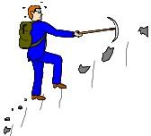April Field Trip (2) Report - Black Mountain Kyanite and Mica Prospects

The 2nd April 2022 FGMC field trip was a return visit to my family property in Black Mountain, N.C. There were six members in attendance, including Gloria Pike, Brent Beck, Brian Burdette, Koi Grimes, Stephen Grimes and Charles Whicker. Weather was excellent and it was a beautiful day in the mountains of North Carolina. Gloria arrived early and found some nice kyanite specimens along the edge of a field above the fann house. Brent and I explored some old mica prospects high on the mountain with his metal detector but oddly did not find any old mining artifacts. By late morning everyone had arrived so we all made the climb to the kyanite prospect and dug in the old pit and tailings. For lunch we grilled hot dogs brought by Koi and Stephen. After lunch we climbed to the mica prospect and dug mica books. Of course, we were accompanied by my four-legged rockhounds Shelley and Basil, who slept all day on Sunday trying to recover. Thanks to everyone who attended!

Charles Whicker
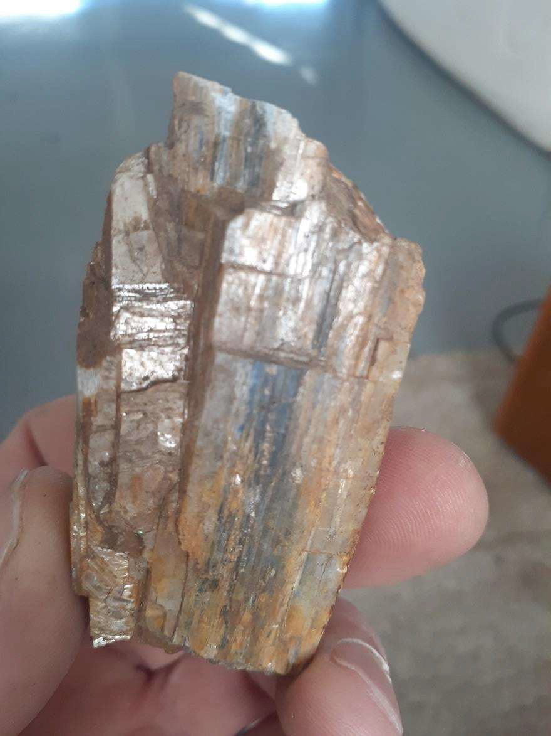

I On-Line Signup for Field Trips
Stephanie Myers, our Web Master and computer wizard , has set up a sign-up "sheet" on the Club' s web site. We would like for members to use this to indicate their intention to attend our upcoming field trips.

I April 2022 Meeting Minutes
April 21, 2022 FGMC Meeting Minutes

Thirteen members present (in-person meeting) and six members signed into the Zoom presentation. Our speaker was Brian Burdette and he showed and explained the process of preparing/cutting opals. Thanks to members that provided our refreshments this month: Stephanie Myers and Jay Wilhelmi.

Prizes Awarded

- Door prize drawing won by Koi Grimes.
- FGMC Gift Membership for 2022 - Jeff & Erin Hollows
- $25 Gift Card - Eric Williams Upcoming events:
- April 23 - Black Mountain Kyanite Prospect lead by Charles Whicker
- May 28 - Danville, Kentucky for Geodes lead by Jeff Hollows

Refreshments needed for upcoming meetings-Contact Jeanne Schlottman.
- Scott Brouhle signed up for May (one person is already signed up)
- One person or family for June (one person is already signed up)
- Koi Grimes signed up for July (one person is already signed up)

Respectfully submitted by Lisa Reed, Secretary, FGMC

FORSYTH GEM AND MINERAL CLUB, INC.
Membership Application For the Year 2022
Date:

Member Name:

Additional Family Members:

Address:

Street
City
State Zip

Telephone(s): Home: ( ) Work: ( )

Cell-1: ( ) Cell-2: ( )

E-Mail Address-1: _@

E-Mail Address-2: _@

Annual Dues of $15.00 are payable January 1st for the current year, per family (mailing address). Dues are reduced to $8.00 per family, if joining after July 1st of the year.

Checks should be made to: Forsyth Gem and Mineral Club, Inc. I am interested in the following activities (check all that apply):

_ Mineral Collecting
_ Lapidary
_ Jewelry Making
Fossils
_ Faceting
_ Wire Wrapping
_ Gold or Silver Smithing
_Carving
Other

I would like to help with the Annual Gem and Mineral Show? Yes No
Circle Yes or No
Areas needing volunteers work in are:

Setup & Display Case Assembly Club Area Setup & Table Covering Admission & Information
Grab Bag and Geode Sales
Display Case Takedown and Loading Dealer Dinner
Geode Cutting (Saw Operator)

Please complete and return to the Club's Treasurer, Jay Wilhelmi, at the address below.

Forsyth Gem and Mineral Club
P.O. Box 422
Pfafftown, NC 27040

Nature's Treasures
Nature's Treasures is the monthly newsletter of the Forsyth Gem and Mineral Club.

President: | Ken Reed
Vice President: | Charles Whicker
Secretary: | Lisa Reed
Treasurer: | Jay Wilhelmi
Directors: | Scott Brouhle
 | Sherry Marion
 | Stephanie Myers
 | Jeff Schlottman
Hospitality Chair: | Jeanne Schlottman
Newsletter Editor: | Jay Wilhelmi
Web Master: | Stephanie Myers

The Greensboro Gem and Mineral Club Inc.
Greensboro, North Carolina
Vendor Contract

Piedmont Open Air Gem, Mineral & Jewelry Show
Piedmont Triad Farmers Market Sandy Ridge Road at 1-40
Colfax, North Carolina
Dealer setup 7:00am Show Hours- 9:00am to 5:00pm
Saturday JUNE 4, 2022
l0'xl0' booth size is $60. Double sizes are available.
Please make checks payable to Greensboro Gem and Mineral Club Inc.

Business name: Description of exhibit:

Application Date: _

Return this copy to:

Greensboro Gem and Mineral Club Mary Pegram
521 West Mountain Street Kernersville, NC 27284 336-918-8634
ggmc.rocks@gmail.com
Postmarked by May 22, 2021
Dealer Contact Name: --------------
Address: City, State and Zip Code: _
Phone: Website: EmaiI address:

Size booth required: 10 X 10
$60.00 Member $50 10 X 20
$100.00 Member $85

If Electricity is needed there is an additional $10.00 fee. Please state reason needed as spaces are limited.
Payment must accompany application. Check or money order preferred. $5 credit card service fee. PayPal and Square payments are also accepted.
There will be a $25 late fee for applications postmarked after May 22. Absolutely no applications accepted after June 1st•

The Dealer hereby agrees:

- To be responsible for collecting 7% Sales Tax on merchandise sold; and to be responsible for filing those taxes collected with the State of North Carolina.
- To refrain from sub-leasing any part of the allotted space, and to restrict displays to assigned space. Please don't ask your neighbor to move. Spaces are generous in size. Please see a Club volunteer to help you work out any issues.

The Greensboro Gem and Mineral Club Inc.
Greensboro, North Carolina
Vendor Contract

- No 'Show Special' signs permitted. NO EXCEPTIONS!
- The show is rain or shine and all booth materials are to be provided by the merchant.
- Vendors bring their own tables and canopy/tent, chairs. GGMC does not provide or rent out these. You must stake or weigh down all canopy/tents. Surface is a grassy field.
- Vendors are responsible for draping the front of their tables. Draping from canopy on more than one side is discouraged. Visibility by vendors and patrons is preferable. If you do require draping on more than one side, please notate on application so you can be located on the back row.
- NO ALCOHOL PERMITTED.
- Food vendors and a Cafe are on site at the Farmers Market, or you may bring your own food.
- Restrooms are nearby.
- No pets are allowed.
- No portable music is to be played.
- No vendor vehicles are allowed in vendor area once show opens. Vehicles MUST be removed from grass area, even those on back row, prior to sales commencing. After the Show, please pack up your merchandise before bringing vehicles in.
- Vendor setup is 7:00 AM to 9:00 AM. Breakdown is 5:00 PM to 7:00 PM.
- No vendors will be allowed to take down before show is closed at 5:00PM, unless prior approval given from Show Chairman.
- Vendors are responsible for their own booth. Leave the area as you found it. CLEAN.
- Once contract and payment in full is received, a confirmation notice will be sent out.
- Please indicate what size booth you require: 10x10 for $60.00 or 10x20 for $100.00. Club Member rates are $50 for 10 X 10; $85 for 10 X 20.
- Vendors agree to comply with all Municipal rules and regulations, the policies of the Facility being utilized to hold the show, and the rules set forth by the Show Committee. The dealer releases and discharges the Greensboro Gem and Mineral Club, Inc., its members and the Show management from any responsibility, liability, loss or damage of any type. If for any reason the show has to be canceled prior to 30 days before setup, the applicant waives any claims - except for monies paid.
- A Name Tag is required for all vendors. A generic name tag will be provided for vendor's helpers. Show Volunteers will be wearing ID tags and are to wear an orange shirt.
- Check in at Club Hospitality booth, Location #1, upon arrival to pick up Dealer packet. The packet will include a coupon for a door prize from your booth. Simply choose the dollar amount you wish to offer and sign it. These will be used for hourly prizes and assures that the winner will visit your booth.
- By returning this contract you agree to all terms and conditions as set forth above.

