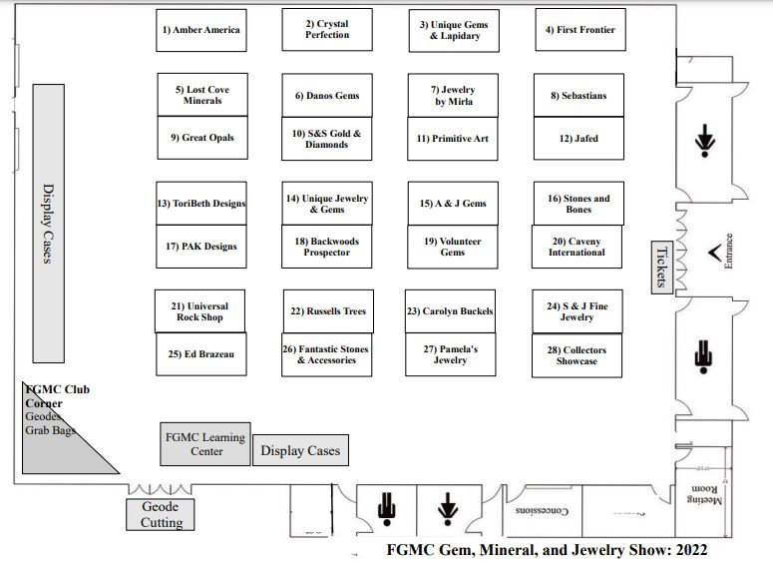Dealers Listing:

A & J Gems (Booth 15)
Amber American (Booth 1)
Backwoods Prospectors, Inc (Booth 18)
Carolyn Buckels (Booth 23)
Caveny International (Booth 20)
Collector Show Case (Booth 28)
Crystal Expressions (Booth 25)
Crystal Perfection (Booth 2)
Danos Gems (Booth 6)
Fantastic Stones & Accessories (Booth 26)
First Frontier, Inc (Booth 4)
Great Opals (Booth 9)
Javed’s International Imports (Booth 12)
Jewelry by Mirla (Booth 7)
Lost Cove Minerals (Booth 5)
PAK Designs (Booth 17)
Pamela’s Jewelry (Booth 27)
Primitive Art (Booth 11)
Russell’s Trees & Treasures (Booth 22)
S & J Fine Jewelry (Booth 24)
S & S Gold & Diamonds (Booth 10)
Sebastian’s Fine Jewelry (Booth 8)
Stones & Bones Collections (Booth 16)
ToriBeth Designs (Booth 13)
Unique Gems and Lapidary Art (Booth 3)
Unique Jewelry and Gems (Booth 14)
Universal Rock Shop (Booth 21)
Volunteer Gems (Booth 19)

